Mechanisms of Religious Rhetoric and Political Mobilization

Sean Rao

December 1, 2021

University of Maryland

Abstract: Does ideology, defined as an organized set of normative ideas about the world, provide an advantage in mobilization for political entrepreneurs? While research on insurgents suggests that religious and strong secular ideologies facilitate violent mobilization, I look for evidence that a political entrepreneur’s ideology can change the expected utility of participation for voters in conventional, electoral mobilization. I investigate mechanisms which link ideological framing to political mobilization through a survey experiment of 507 university undergraduates. The experimental treatment displays a hypothetical campaign advertisement justifying a candidate’s position on an explicitly religious basis, while the control lacks religious content. Participants reading the religious justification are more likely to believe the candidate is strongly committed to the policy, more likely to believe that religious people will support the candidate, and if they are religious themselves, more likely to believe the policy is important. However, I find no evidence that participants in general are more likely to support the candidate or to believe that people like them will. The results suggest that ideological claims can signal a political entrepreneur’s strong commitment to a policy goal, increase support of that goal among ideological followers, and suggest to the general public that those followers will support the entrepreneurs, but ideological claims can neither increase support for a political entrepreneur among the general public nor create the impression that it will do so. The results show that ideological political entrepreneurs have specific, but limited, advantages in earning popular support.

Introduction
Does ideology, defined as an organized set of normative ideas about the world, provide an advantage in mobilization for political entrepreneurs? I ask this question to make two contributions to the research literature. First, research on violent insurgents suggests that some ideologies, such as religious ideologies, facilitate mobilization, for example, by generating a shared expectation of costly participation (Berman 2009). Here, I look for evidence of an effect from ideology on nonviolent, electoral mobilization. Second, based on this evidence, I extend the study of ideology in individual political behavior by showing that ideology changes how voters evaluate candidates and policy importance, and, therefore, that ideology changes how voters estimate the expected utility of supporting a candidate. Most research on the impact that strong ideologies, such as religion, have on voting has instead focused on priming a voter’s identity with a group (McDermott 2009) or signaling a candidate’s personality traits (Clifford and Gaskins 2016), rather than signaling a commitment to pursuing political goals. So, this research also builds on the study of religious framing in electoral campaigns. Because I define ideology as an organized set of normative ideas about the world, religion serves as an example of ideology. While not the only form of this kind of ideology, religion is probably more commonly used in politics in the United States than other organized sets of normative ideas about the world, such as Marxism. Therefore, I investigate the question of ideological mobilization in nonviolent politics with a survey experiment of religious political rhetoric on a sample of 507 university undergraduates. The results show that ideological political entrepreneurs have specific, but limited, advantages in earning popular support in electoral campaigns.
Review of Relevant Literature
By ideology, I do not mean policy positions on a left to right scale, but a “way of understanding the world” (Ugarriza and Craig 2012, 450). Ackerman and Burnham (2019, 5), surveying nearly 300 scholarly works on ideology, define ideology as “a system of societal beliefs that is judgmental of the way things are and/or ought to be, is generally intended to be propagated, and claims exclusive explanatory power within the domain it encompasses” (Ackerman and Burnham 2019, 7). This kind of ideology sets standards for society as a whole, not merely for policy. Religious or Marxist ideologies provide the most obvious examples. While these are often studied merely as group labels, this project helps respond to the call in international relations and comparative politics for a more rigorous investigation of ideology (Ugarriza and Craig 2012; Gutiérrez-Sanín and Wood 2014; Kalyvas 2015; Schubiger and Zelina 2017; Cederman and Vogt 2017, 2005-6; Belgioioso 2018, 652) by examining several mechanisms of mobilization which change expectations of the utility of political participation.
Ideological mobilization through signals of commitment has been studied in violent organizations but not in nonviolent or electoral politics. Violent rebels, for example, receive “solidary rewards” from being part of an organization, as well as “functional rewards”, utility perceived from participating in the activity of rebellion itself (Gates and Nordås 2010, 19). Functional rewards are generated by tying the political activity to belief in the larger ideological principles. For example, rebels using religious ideology “can offer cheap, deferred compensation in the form of an ‘eternal afterlife’ or ‘rewards in paradise’”. Denying these rewards is “a potentially devastating type of personal punishment (eternal damnation in the case of Christianity and excommunication in the case of Islam) that is both costless to enforce [for the political actor] and impossible for targets to escape” (Walter 2017, 9). Functional rewards are not available to organizations that do not adhere to an overarching, deep ideology.
While solidary rewards are available to other organizations, this kind of ideology also increases solidary rewards. Because of the potential for functional rewards, the cost of defecting from the group interest is smaller and trust is higher. This increases the value of the social ties among members of the group, increasing the value of solidary rewards, even if functional rewards are not strictly necessary for the existence of solidary rewards (Gates and Nordås 2010, 18-19). For example, Islamists may be able to more effectively reap political rewards from providing material services because their religious ideology makes them seem more trustworthy (Cammett and Luong 2014). Thus, functional and solidary rewards derived from a comprehensive ideology are not merely reducible to mechanisms of social identity, though the two may build on each other. While this has been somewhat studied for violent (Berman 2009, 20-2; Walter 2017) and nonpolitical groups (Berman 2000, 905, 908), I examine whether or not there is evidence for similar mechanisms linking ideology and mobilization in nonviolent and electoral politics.
This extension of the study of ideology also builds on the literature studying religious framing in electoral politics. For example, Americans find Evangelical politicians to be more competent and trustworthy than those with no religion (though they do not necessarily favor them) (McDermott 2009, 348) and candidates may trigger this effect by appealing to religion (Clifford and Gaskins 2016, 1066). Religious cues in campaign ads can make religious traditionalists more likely to believe that a candidate shares their values (Weber and Thornton 2012). Similarly, explicit religious rhetoric in favor of a candidate makes religious voters more favorable but turns off other voters, while implicit rhetoric has less of a negative effect (McLaughlin and Wise 2014, 376-9; Albertson 2015). These mechanisms all link candidates to stereotypes through an information shortcut, but this project looks for the impact of religious framing on the expectations utility of supporting a candidate by increasing perceptions of a candidate’s commitment to a particular policy and the expected value of that policy. Thus, this project extends research on religious cues as well as extending the research on ideology and commitment mechanisms from violent to electoral politics.

Theory and Hypotheses
I look for the presence of three individual-level mechanisms tying ideological framing to political mobilization. Even though I am interested in several forms of strong ideology, I focus on religious ideology here because explicit and direct rhetoric from other strong ideologies, such as Marxism, is much rarer than religion in American politics. I focus on candidate evaluation rather than partisan evaluation because neither American party adheres to a religious ideology. Though Republicans use religious rhetoric more often than Democrats, the Republican Party does not hold a religious ideology as I have defined it because it does not derive its platform from religious principles. This contrasts with, for example, the Islamic Movement in Israel, which has an overarching, primary goal of pursing Islamic da`wa (religious revival). Its political goals are a means of achieving da`wa, rather than the reverse (Rosmer 2012, 340). Given the limitations of the partisan landscape, I examine the reaction to explicitly religious appeals from a hypothetical candidate rather than a party.
When a candidate frames a political issue as a religious imperative, that candidate signals something about the candidate’s own incentive structure and, that, in turn, may change the voters’ incentive structure in supporting the candidate for several reasons. First, religion imposes standards for behavior and divine punishments for violating them. Violating a religious promise would risk a spiritual punishment. Because a religious candidate would expect such punishment and voters can, in turn, expect that the religious candidate expects punishment, voters, regardless of their own beliefs, should be more likely to believe that a candidate who justifies a policy in religious terms is committed to achieving a religiously based policy and is not simply power-seeking (Walter 2017, 17). Stereotypes that religious candidates are more trustworthy (McDermott 2009, 348; Clifford and Gaskins 2016) may strengthen this effect.
Hypothesis 1a: Respondents will be more likely to believe that a candidate is strongly committed to a policy which the candidate justifies in religious terms outside of a moralized context.
A context of harm can moralize an issue (Wisneski, Hanson, and Morgan 2020), and those who hold moralized views are unlikely to compromise (Arceneaux 2019). So, if the candidate justifies policy with religious rhetoric in a context of harm, a life or death situation, respondents should expect that the candidate is particularly committed.
Hypothesis 1b: Respondents will be more likely to believe that a candidate is strongly committed to a policy which the candidate justifies in religious terms in a moralized context.
Second, the signal from the candidate using religious rhetoric may also change the incentive structure of voters. I expect that respondents who hold strong religious beliefs themselves should more highly value a policy goal when a candidate justifies it as a religious goal. Once so framed, the policy goal helps respondents achieve religious satisfaction (Gates and Nordås 2010, 9; Walter 2017).
Hypothesis 2a: Religious respondents should care more about achieving a policy if a candidate justifies the policy in religious terms outside of a moralized context.
This should be particularly so when the issue is moralized as it makes supporting the issue a greater imperative and less amenable to compromise (Skitka and Bauman 2008).
Hypothesis 2b: Religious respondents should care more about achieving a policy if a candidate justifies the policy with religious rhetoric in a moralized context.
Third, religion creates shared understandings of society and relationships between individuals. When these shared understandings are applied to a political issue, recipients who recognize the symbols will not only understand these symbols (McLaughlin and Wise 2014; Albertson 2015), but also expect that others will understand them similarly. Therefore, respondents should also expect that others believe in the commitment of the candidate, and therefore, support the candidate, when the candidate uses religious framing, and particularly, when the candidate uses moralized religious framing, which strengthens that signal of commitment.
Hypothesis 3a: Respondents will be more likely to believe that other people will support a candidate when the candidate justifies the policy in religious terms outside of a moralized context.
Hypothesis 3b: Respondents will be more likely to believe that other people will support a candidate when the candidate justifies the policy in religious terms in a moralized context.
If voters support the policy, then they should be more likely to support a candidate whom they believe is truly committed to achieving the policy because they can expect a greater expected utility from voting for that candidate. I expect that an increased belief in the candidate’s dedication to the policy will mediate an increased preference for the candidate.
Hypothesis 4: Respondents who support a policy should be more likely to favorably evaluate a candidate when that a candidate justifies the policy in religious terms by means of estimating a greater commitment of that candidate to that policy.
Research Design

I test these hypotheses by means of a survey experiment. A sample of 635 participants was recruited from several undergraduate political science courses at the University of Maryland through the University of Maryland Government and Politics Experimental Laboratory. Removing noncitizens and inattentive respondents yielded a sample of 507 participants. While a university sample is by no means representative of the population at large, it makes a hard test for the effect of religious rhetoric. Since the sample population is likely to be younger, less religious, more urban, more educated, and more left-leaning than the average population and especially than the conservative populations usually associated with religious rhetoric in the United States, any results supported on this sample should be seen as relatively strong evidence.
The experimental conditions consisted of a written campaign advertisement from a hypothetical candidate for county board. Since Republicans use religious rhetoric more than Democrats and because of the extreme power of partisanship on opinions, particularly on a Democratic-leaning sample, I have taken three steps to minimize the interference of partisanship with the treatment: first, the election will be local, rather than state or federal, and, second, each respondent received a version of the advertisement presenting the candidate as a member of the respondent’s preferred party. Respondents do not identify with or lean towards either major party received a version which presented the candidate as an independent. Third, I present all results on Republican and Democratic subsamples as well as the whole sample.
For each party, I used a 2 by 2 design of four conditions. In one dimension, randomly assigned respondents to read one of two versions of the advertisement appropriate to their party identification. In one version, the candidate justified support for a policy in explicitly religious terms. In the other, the candidate supported the same policy without any religious terminology. The policy was solving traffic congestion to minimize the chance that the respondents varied in their original preferences on the policy. In the other dimension, conditions varied by whether the candidate moralized the problem of traffic. In the non moralized condition, the candidate advocated for the reduction of traffic congestion due to the time wasted by traffic delays. In the moralized condition, the candidate mentioned deaths due to traffic collisions. I named the candidate “Taylor Morris” to be as neutral as possible in gender and race and provided no picture or pronouns of the candidate. Thus, the design compares whether or not religious rhetoric affects the respondents’ importance attached to traffic problems and whether they believe the candidate is committed to the problem. I additionally compare whether this mechanism is impacted by priming a moralized situation of harm. Table 1 shows the Democratic party conditions. (Republican and independent conditions differed only in the word “Democrat” and its color. See Table 3 in the Appendix for all the conditions and Appendix 5 for all the survey questions.)
Because religious rhetoric may have differential effects depending on partisanship, a respondent’s own religious identity, and practice, and assumptions made about the candidate’s background, I test the hypotheses with logistic regression models, both binary and ordinal, that control for these factors. For the dependent variables, respondents will be asked how much they agree with the statements that the candidate’s is highly committed to the policy (Hypotheses 1a-b), that the policy is important to the respondent (Hypotheses 2a-b), that people like them believe the candidate is highly committed to the policy, and that religious people believe the candidate is highly committed to the policy (Hypotheses 3a-b). Religious respondents (for Hypotheses 2a-b) will be identified through the question of how important religion is in the respondent’s life. Those who say that religion is at least slightly important will be coded as religious while those who say that religion is not at all or not very important will be coded as not religious. The five-level measure of religious importance will be a control in all models. Other control variables are sex and the religious background of the respondent. Partisanship is controlled in models including both parties. Because few nonwhite Republicans (17 out of 507) and independents (16 out of 507) are in the sample, race is not controlled except in models on the Democratic subsample.
Table 1: Experimental Conditions (for Democratic respondents)
Control: Non Moralized (Democratic) | Treatment: Non Moralized (Democratic)
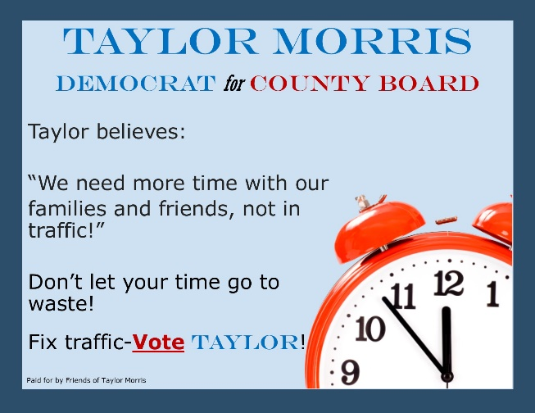 | 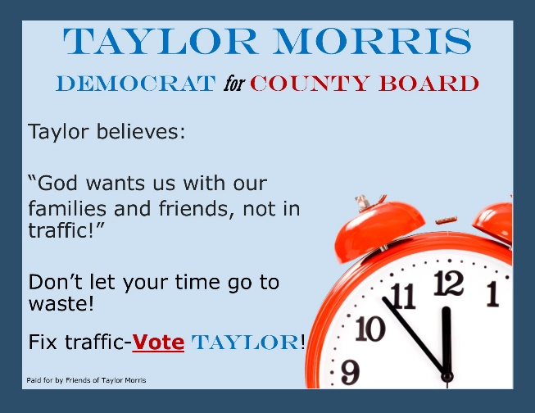
Control: Moralized (Democratic) | Treatment: Moralized (Democratic)
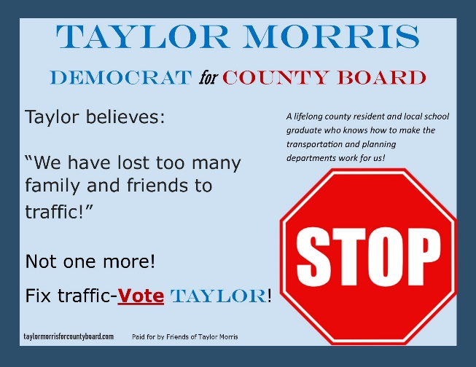 | 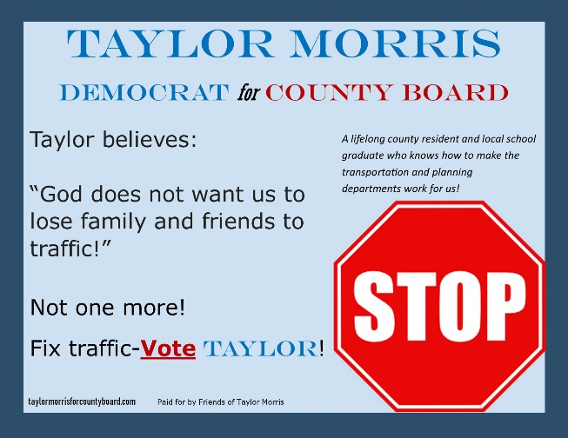

Finally, for Hypothesis 4, I perform mediation analyses on the part of the sample which considers the policy important. The mediator model being the impact of the religious rhetoric treatment with believing the candidate is committed to the policy and the dependent variable being the willingness to vote for the candidate. This will allow me to test whether increased credibility of promises created by the religious rhetoric, if I indeed find evidence for that, can increase support for the candidate.

Results

I analyzed the data using R 4.1.2 software (R Core Team 2021), fitted ordinal logistic regression models using the {MASS} package (Venables and Ripley 2002), and calculated the average marginal effect (Hanmer and Kalkan 2013) on predicted probabilities using the {DAMisc} package (Armstrong 2020). I used the {calibrate} (Graffelman and Van Eeuwijk 2005) package in the plots. I present the plots of the changes in predicted probabilities. Tables of the changes in predicted probabilities appear in Appendix 2, coefficients for the binary logistic regressions in Appendix 3, and coefficients for the ordinal logistic regressions in Appendix 4.
For Hypothesis 1a, I find limited support that the religious rhetoric condition increases perceptions of the candidate’s commitment to the policy. The binary model (Figure 1), with those who somewhat or strongly agree that the candidate is committed being coded as believing the candidate is committed, does not produce significant results. However, among Republicans, there is an increase in the predicted probability of believing the candidate is committed to the policy which approaches significance. Additionally, the ordinal model shows that there is a significant increase in the predicted probability of respondents strongly agreeing that the candidate is committed (level 4 in the Figure 2) due to the religious prime across both parties and the complete sample. For Republicans, there is a significant increase in the probability of somewhat agreeing, too, and a decrease in the predicted probability of disagreeing that the candidate was committed to the policy. (No Republicans strongly disagreed that the candidate was committed, so no level 0 is estimated for them.) For Democrats, there was little change on the predicted probability of disagreeing that the candidate was committed. Thus, while the binary model provides little evidence, the ordinal model suggests that religious rhetoric does increase the chance that a candidate can signal commitment to achieving a policy goal.
Contrary to initial expectations, however, this evidence, at least for the non moralized condition (Hypothesis 1a), is much stronger among Republicans. Moreover, evidence for Hypothesis 1b was mixed. The moralized religious treatment had an effect, but a weaker one than the non moralized among Republicans and in the whole sample. There is some evidence for Democrats responding better to the moralized version than the non moralized religious rhetoric, though. Therefore, I find Hypothesis 1 supported and conclude that the religious treatment can increase the ability of a candidate to signal commitment to a policy, though the binary results were not significant, and the moralizing effects differ among Republicans and Democrats.
Figure 1 Figure 2

Hypothesis 2, that a candidate using religious rhetoric to justify a policy can increase the support for that policy among religious believers, finds stronger, though also mixed, support. The models to test this hypothesis was run only on respondents that said religion was somewhat or very important in their lives. Changes in predicted probability from the binary model (Figure 3) are again not significant at the 95% confidence level, but some are significant at the 90%
Figure 3 Figure 4
confidence level. In the ordinal model (Figure 4), nearly all subsets show a significant increase in the predicted probability of believing the policy is very important and significant decreases in the predicted probability of believing that the policy is not at all important. Results for the moralized conditions are mixed: among Democrats and in the full sample, the non moralized religious condition has a larger predicted change in probability of believing the policy is important than the moralized version. However, among Republicans, the reverse seems to be true. Therefore, while I cannot conclude anything about the impact of moralizing for Hypothesis 2, I do conclude the candidates can increase the importance of a policy among religious followers by justifying that policy in terms of religion.
I did not find support for Hypothesis 3 as written, across party and regardless of moralization (Figures 5 and 6). There is some evidence that the religious treatment made respondents think that “people like me [the respondent]” would be less, rather than more, likely to support the candidate, especially Democrats. This means that they do not expect that the shared symbolism of religion will be received by people like them, contrary to expectations. This makes some sense, however, because the respondents may perceive religious people as very different from them, a reasonable response as religious rhetoric has often been shown to be a signal of identity in American politics (McDermott 2009; Laughlin and Wise 2014, 376-9; Albertson 2015).
Figure 5 Figure 6
To explore this further, I also ran similar models but, rather than asking if “people like me [the respondent]” would support the candidate, the dependent variable is whether “religious people” would support the candidate. Here, there is very strong evidence in both the binary (Figure 7) and ordinal (Figure 8) models that the religious rhetoric, whether moralized or non moralized, significantly increased the predicted probability of agreeing that religious people would support the candidate. Thus, I still find evidence that the use religious rhetoric by a political entrepreneur can signal to the public that the candidate has a constituency of support. Contrary to my initial expectation, however, the political entrepreneur cannot signal that the public as a whole will support the candidate by the use of religious rhetoric but can signal that the religious public will. This makes sense given not only the previous literature of signaling religious identity or personality traits in American politics (McDermott 2009; Clifford and Gaskins 2016) but also the results above for Hypothesis 2 that showed that political entrepreneurs can increase support for a policy among religious believers through the use of religious rhetoric.
Figure 7 Figure 8
Finally, I turn to Hypothesis 4, that, among those considering the policy important, religious rhetoric would increase the likelihood of willingness to vote for a candidate by the mechanism of increased perceived commitment of the candidate to the policy. Using binary models and mediation analysis from the {mediate} package (Tingley et al 2014) in R, I fail to find any evidence for a mediation effect of candidate commitment on the willingness for vote for the candidate (Table 2). In Figures 9 and 10, I present the estimated changes in predicted probabilities for the models of the predicted probability of believing the candidate is committed to the policy, similar to Hypothesis 1, but only among the respondents who agreed somewhat or strongly that the policy was important to them. This is Stage 1 of the mediation, the mediator models. In Figures 11 and 12, I present the estimated changes in the predicted probability of being willing to vote for the candidate among respondents who agreed that the policy was important to them. This is Stage 2 of the mediation. Even though I find no evidence of a mediation effect, I still identify some effects from these stages separately.
Table 2: Mediation Analysis
Model Type | Treatment | Mediator | Subset | ACME Treated | 95% C.I. Min. (ACME) | 95% C.I. Max. (ACME) | p (ACME) | Significance (ACME) | Total Effect | 95% C.I. Min. (Total) | 95% C.I. Max. (Total) | p (Total) | Significance (Total)
Binary | Religious Treatment | Candidate Commitment | All Parties: Non Moralized | 0.003 | -0.034 | 0.041 | 0.856 |  | -0.048 | -0.190 | 0.106 | 0.516
Binary | Religious Treatment | Candidate Commitment | All Parties: Moralized | 0.004 | -0.015 | 0.027 | 0.680 |  | -0.188 | -0.333 | -0.041 | 0.014 | *
Binary | Religious Treatment | Candidate Commitment | All Parties: Both Morals | 0.003 | -0.017 | 0.022 | 0.726 |  | -0.126 | -0.227 | -0.017 | 0.034 | *
Binary | Religious Treatment | Candidate Commitment | Republicans: Non Moralized | 0.032 | -0.068 | 0.149 | 0.500 |  | 0.001 | -0.317 | 0.379 | 0.952
Binary | Religious Treatment | Candidate Commitment | Republicans: Moralized | 0.023 | -0.070 | 0.162 | 0.556 |  | 0.071 | -0.280 | 0.350 | 0.706
Binary | Religious Treatment | Candidate Commitment | Republicans: Both Morals | 0.034 | -0.027 | 0.124 | 0.300 |  | -0.030 | -0.267 | 0.207 | 0.784
Binary | Religious Treatment | Candidate Commitment | Democrats: Non Moralized | -0.006 | -0.056 | 0.044 | 0.800 |  | -0.066 | -0.248 | 0.111 | 0.464
Binary | Religious Treatment | Candidate Commitment | Democrats: Moralized | -0.0003 | -0.029 | 0.030 | 0.978 |  | -0.207 | -0.373 | -0.040 | 0.018 | *
Binary | Religious Treatment | Candidate Commitment | Democrats: Both Morals | -0.001 | -0.021 | 0.016 | 0.912 |  | -0.147 | -0.263 | -0.020 | 0.020 | *
*p<.05; +p<.1
Figure 9 Figure 10

Figure 11 Figure 12
Figures 9 and 10 show results similar, but somewhat stronger than the results for Hypothesis 1. While the binary model is still not significant, the effect among Republicans is near significance; this is corroborated by the significant effect found among Republicans in the ordinal models. Smaller, but also significant effects are found among Democrats and the whole sample. Except possibly among Democrats, the moralized treatment did not perform better than the non moralized. Therefore, these models provide additional support for the idea that a candidate can signal commitment to a policy through justifying a policy in religious rhetoric.
By contrast, the Stage 2 models (Figures 11 and 12) contradict my expectations entirely. Respondents who care about the issue are significantly less likely to be willing to vote for the candidate when receiving religious rhetoric and particularly when receiving the moralized version. This indicates that candidates cannot necessarily generate greater support among the public interested in a policy by means of justifying the policy in religious rhetoric. Moralizing the issue only makes this worse from the perspective of a candidate.

Conclusion

In this paper, I investigated several mechanisms that link ideology to political behavior through impacting perceptions of a policy promise. Since I define ideology as an organized set of normative ideas about the world, religion is a particular form of ideology and probably the most relevant form in American politics. The unrepresentative sample of generally secular university students makes this a hard test to find evidence for an effect of religion. Nevertheless, I find some evidence for several mechanisms: first, religious rhetoric increases the probability that a candidate’s promise to pursue a policy is seen as credible. Second, religious rhetoric allows a candidate to increase the importance of a policy among religious respondents. Third, while a candidate cannot create a perception that the public at large supports him by using religious rhetoric, the candidate can create a perception that religious believers will support the candidate. Fourth, contrary to expectations, the increase in perceived credibility does not lead to an increase in willingness to vote for the candidate. Finally, also contrary to expectations, moralizing the issue was either irrelevant to the effect of religious framing or, in some cases, reduced it.
This study provides evidence in a nonviolent, electoral, and stable democratic context for mechanisms of signaling credibility which have previously been studied in violent contexts (Berman 2009; Walter 2017). This suggests that some of those mechanisms argued to be at work in violent contexts are present in a nonviolent stable electoral context, too, while others are not. Candidates can increase their perceived commitment to a policy and generate an expectation that ideological followers will support them, but they are not able, at least not in this context, to translate this perception of greater resolve to increased support in the general public, nor are they able to generate a common expectation that others in the general public will support them, contrary to what Walter (2017) argued for violent contexts. Thus, either the nonviolent stable electoral context is different in this regard, as Walter (2017) assumed but could not show, or these mechanisms do not in fact operate in violent contexts as theorized. Berman (2009) argued that credibility can only generate mobilization when combined with costly signals; since this signal is not costly, this may explain why the religious framing did not increase the willingness to vote for the candidate even as the perceived commitment of the candidate to the policy did increase. Thus, this paper provides empirical evidence for mechanisms and their scope conditions which have been often theorized but rarely tested.
This research also shows that religious rhetoric can change the general public’s expectation of commitment to a policy as well as religious voters’ view of the importance of that policy. This reveals additional mechanisms of religious rhetoric impacting voting behavior besides what has previously been argued in research on American politics, which has focused more on identity and perceptions of the candidate’s personality (McDermott 2009; Clifford and Gaskins 2016). Instead, this research suggests that it is important to examine how and when religion impacts the evaluation of policy promises from a candidate.
This paper shows that religious rhetoric can increase the perceived commitment of a candidate to a specific policy, increase religious voters’ importance of that policy, and create a perception that religious voters will support a candidate, even while the candidate may still have difficulty increasing the willingness to vote for that candidate. This provides important empirical evidence for mechanisms which have previously been examined or theorized in violent contexts and provides an important empirical test of the scope conditions outside of that context, as well as showing that religion can impact perceptions of policy, commitment to policy, and expectations of other voters’ behavior, rather than only priming identity or personality traits. Moralizing an issue is unrelated to these mechanisms. Future research will need to further identify the scope conditions of these mechanisms and test whether nonreligious ideologies have similar impacts.

References
Ackerman, Gary A., and Michael Burnham. 2019. “Towards a Definition of Terrorist Ideology.” Terrorism and Political Violence DOI: 10.1080/09546553.2019.1599862
Albertson, Bethany L. 2015. “Dog-Whistle Politics: Multivocal Communication and Religious Appeals.” Political Behavior 37: 3-26. DOI: 10.1007/s11109-013-9265-x
Armstrong, Dave. 2020. “DAMisc: Dave Armstrong's Miscellaneous Functions.” Version 1.6.2. R Package. https://CRAN.R-project.org/package=DAMisc
Belgioioso, Margherita. 2018. “Going Underground: Resort to Terrorism in Mass Mobilization Dissent Campaigns.” Journal of Peace Research 55 (5): 641-655. DOI: 10.1177/0022343318764795
Berman, Eli. 2000. “Sect, Subsidy, and Sacrifice: An Economist’s View of Ultra-Orthodox Jews.” The Quarterly Journal of Economics 115 (3): 905-953.
Berman, Eli. 2009. Radical, Religious, and Violent: The New Economics of Terrorism. Cambridge, MA: MIT Press. Berman, Eli, and David D. Laitin. 2008. “Religion, Terrorism, and Public Goods.” Journal of Public Economics 92: 1942-1967.
Cederman, Lars-Erik, and Manuel Vogt. 2017. “Dynamics and Logics of Civil War.” Journal of Conflict Resolution 61 (9): 1992-2016. DOI: 10.1177/0022002717721385
Clifford, Scott, and Ben Gaskins. 2016. “Trust Me, I Believe in God: Candidate Religiousness as a Signal of Trustworthiness.” American Politics Research 44 (6): 1066-1097. DOI: 10.1177/1532673X15608939
Cunningham, Kathleen Gallagher. 2014. Inside the Politics of Self-Determination. Oxford: Oxford University Press.
Gates, Scott, and Ragnhild Nordås. 2010. “Recruitment and Retention in Rebel Groups.” Working Paper. Center for the Study of Civil War, Peace Research Institute Oslo (PRIO).
Gutiérrez-Sanín, Francisco, and Elisabeth Jean Wood. 2014. “Ideology in Civil War: Instrumental Adoption and Beyond.” Journal of Peace Research 51 (2): 213-226.
Graffelman, Jan, and Fred Van Eeuwijk. 2005. “Calibration of Multivariate Scatter Plots for Exploratory Analysis of Relations within and between Sets of Variables in Genomic Research.” Biometrical Journal 47(6), 863-879. DOI: 10.1002/bimj.200510177
Hanmer, Michael J., and Kerem Ozan Kalkan. 2013. “Behind the Curve: Clarifying the Best Approach to Calculating Predicted Probabilities and Marginal Effects from Limited Dependent Variable Models.” American Journal of Political Science 57 (1): 263–277. DOI: 10.1111/j.1540-5907.2012.00602.x
Hlavac, Marek. 2018. “stargazer: Well-Formatted Regression and Summary Statistics Tables.” Version 5.2.2. R Package. http://CRAN.R-project.org/package=stargazer
Kalyvas, Stathis N. 2015. “Is ISIS a Revolutionary Group and if Yes, What Are the Implications?.” Perspectives on Terrorism 9 (4): 42-47
McDermott, Monika L. 2009, June. “Religious Stereotyping and Voter Support for Evangelical Candidates.” Political Research Quarterly 62 (2): 340-354.
McLaughlin, Bryan, and David Wise. 2014. “Cueing God: Religious Cues and Voter Support.” Politics and Religion 7 (2): 366-394. DOI: 10.1017/S175504831400008X
Mecham, Quinn. 2017. Institutional Origins of Islamist Political Mobilization. New York: Cambridge University Press.
R Core Team. 2021, November 1. “R: A Language and Environment for Statistical Computing.” Version 4.1.2. R Foundation for Statistical Computing, Vienna, Austria. https://www.R-project.org/
Rosmer, Tilde. 2012. “Resisting ‘Israelization’: The Islamic Movement in Israel and the Realization of Islamization, Palestinization, and Arabization.” Journal of Islamic Studies 23 (3): 325-358. DOI: 10.1093/jis/ets054
Schubiger, Livia Isabella, and Matthew Zelina. 2017 October. “Ideology in Armed Groups.” PS: Political Science and Politics: 948-951. DOI: 10.1017/S1049096517001056
Tingley, Dustin, Teppei Yamamoto, Kentaro Hirose, Luke Keele, and Kosuke Imai. 2014. “mediation: R Package for Causal Mediation Analysis.” Journal of Statistical Software 59 (5), 1-38. http://www.jstatsoft.org/v59/i05/
Ugarriza, Juan E., and Matthew J. Craig. 2012. “The Relevance of Ideology to Contemporary Armed Conflicts: A Quantitative Analysis of Former Combatants in Colombia.” Journal of Conflict Resolution 57 (3): 445-477.
Walter, Barbara F. 2017. “The Extremist’s Advantage in Civil Wars.” International Security 42 (2): 7-39. DOI: 10.1162/ISEC_a_00292
Weber, Christopher, and Matthew Thornton. 2015. “Courting Christians: How Political Candidates Prime Religious Considerations in Campaign Ads.” Journal of Politics 74 (2): 400-413. DOI: 10.1017/S0022381611001617

Appendix 1: Experimental Treatments
Table 3: Experimental Conditions (complete)
Control – Non Moralized | Treatment – Non Moralized
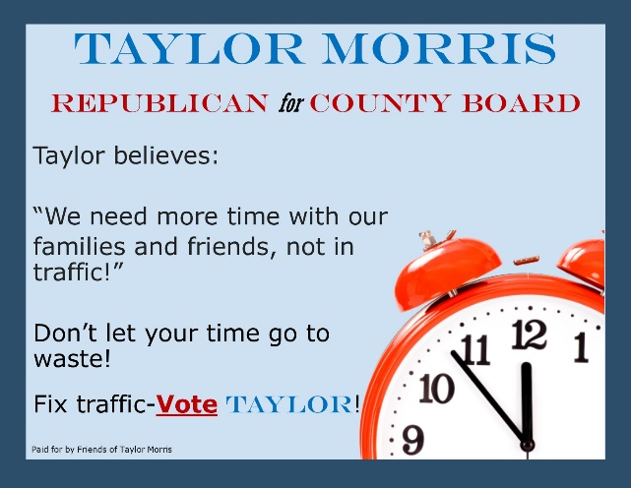 | 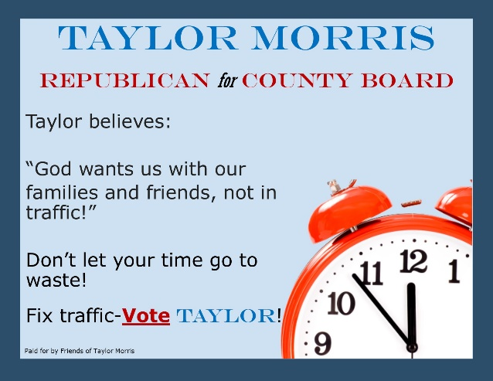
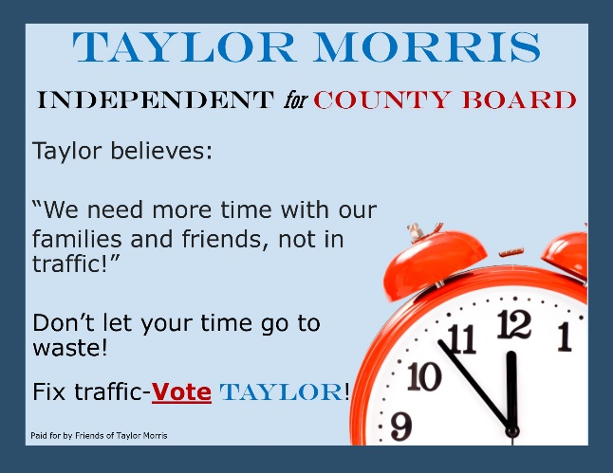 | 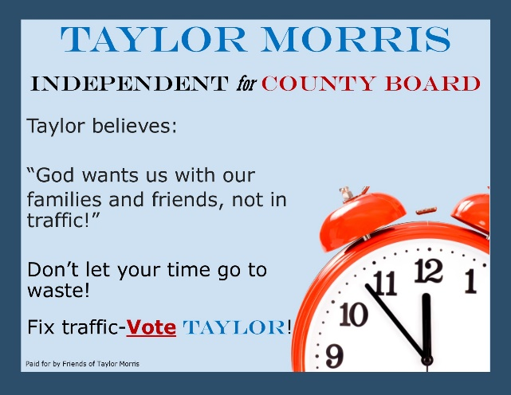

Control – Moralized | Treatment – Moralized
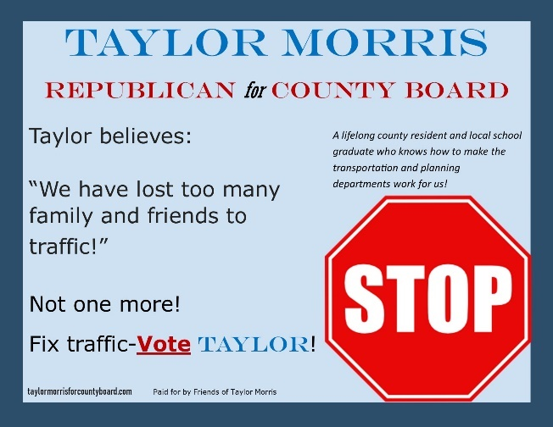 | 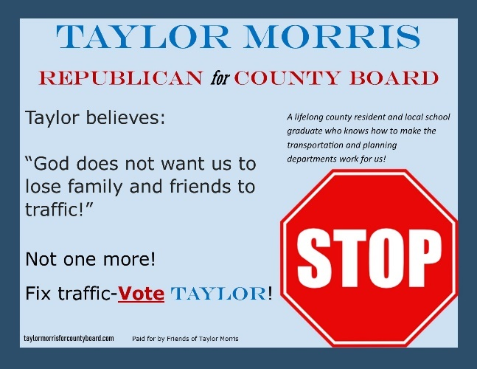
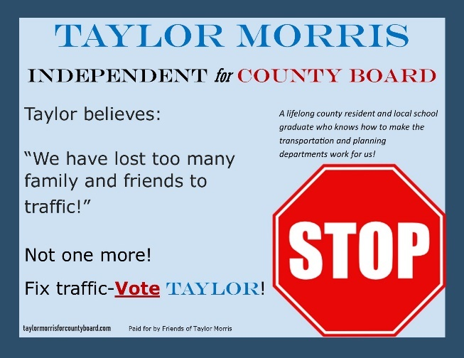 | 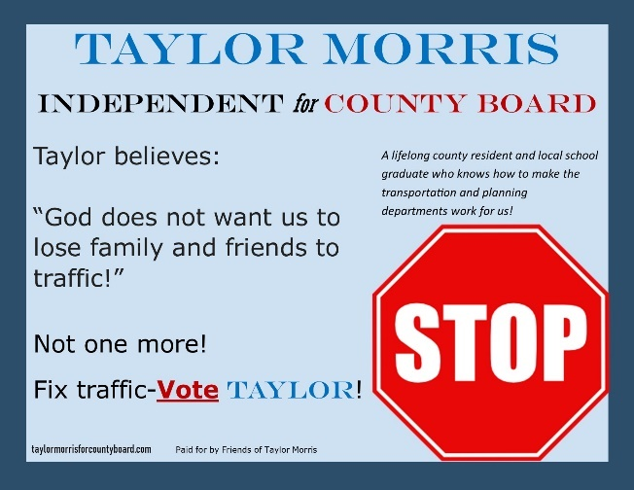
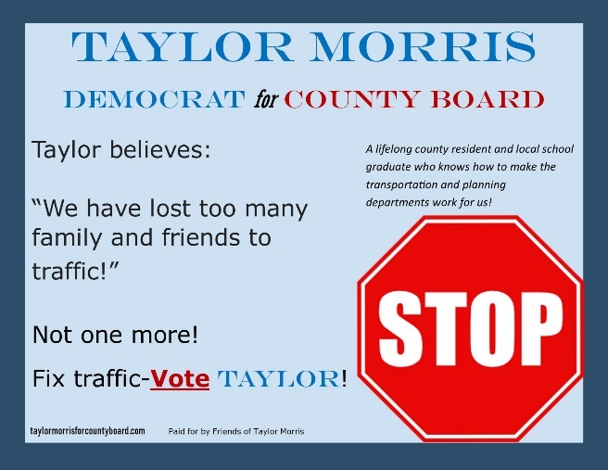 | 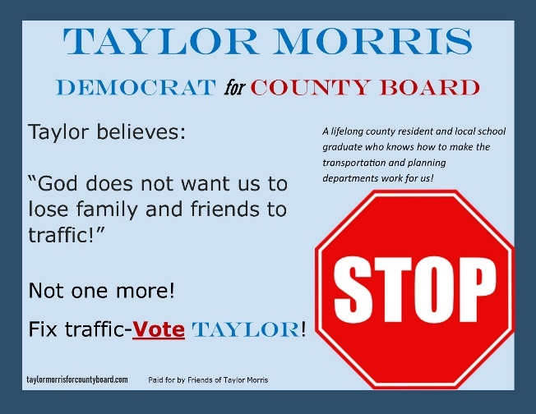

Appendix 2: Tables of Predicted Probability Changes
Table 4: Change in Predicted Probabilities due to Religious Justification Treatment - Binary Models
Dependent Variable | Subset | Change in Predicted Probability
H1: Candidate Commitment | All: Non Moralized | 0.052
H1: Candidate Commitment | All: Moralized | 0.036
H1: Candidate Commitment | All: Both Morals | 0.033
H1: Candidate Commitment | Republicans: Non Moralized | 0.199
H1: Candidate Commitment | Republicans: Moralized | 0.080
H1: Candidate Commitment | Republicans: Both Morals | 0.140
H1: Candidate Commitment | Democrats: Non Moralized | -0.002
H1: Candidate Commitment | Democrats: Moralized | 0.043
H1: Candidate Commitment | Democrats: Both Morals | 0.019
H2: Policy Importance (Religious Respondents) | All: Non Moralized | 0.176
H2: Policy Importance (Religious Respondents) | All: Moralized | 0.127
H2: Policy Importance (Religious Respondents) | All: Both Morals | 0.126+
H2: Policy Importance (Religious Respondents) | Republicans: Non Moralized | -0.120
H2: Policy Importance (Religious Respondents) | Republicans: Moralized | 0.172
H2: Policy Importance (Religious Respondents) | Republicans: Both Morals | 0.144
H2: Policy Importance (Religious Respondents) | Democrats: Non Moralized | 0.209+
H2: Policy Importance (Religious Respondents) | Democrats: Moralized | 0.067
H2: Policy Importance (Religious Respondents) | Democrats: Both Morals | 0.145
H3: Estimated Support by ``People Like Me`` | All: Non Moralized | -0.073
H3: Estimated Support by ``People Like Me`` | All: Moralized | 0.033
H3: Estimated Support by ``People Like Me`` | All: Both Morals | -0.009
H3: Estimated Support by ``People Like Me`` | Republicans: Non Moralized | -0.080
H3: Estimated Support by ``People Like Me`` | Republicans: Moralized | 0.078
H3: Estimated Support by ``People Like Me`` | Republicans: Both Morals | 0.012
H3: Estimated Support by ``People Like Me`` | Democrats: Non Moralized | -0.090
H3: Estimated Support by ``People Like Me`` | Democrats: Moralized | 0.046
H3: Estimated Support by ``People Like Me`` | Democrats: Both Morals | -0.012
H3: Estimated Support by ``Religious People`` | All: Non Moralized | 0.504*
H3: Estimated Support by ``Religious People`` | All: Moralized | 0.501*
H3: Estimated Support by ``Religious People`` | All: Both Morals | 0.521*
H3: Estimated Support by ``Religious People`` | Republicans: Non Moralized | 0.468*
H3: Estimated Support by ``Religious People`` | Republicans: Moralized | 0.352*
H3: Estimated Support by ``Religious People`` | Republicans: Both Morals | 0.467*
H3: Estimated Support by ``Religious People`` | Democrats: Non Moralized | 0.500*
H3: Estimated Support by ``Religious People`` | Democrats: Moralized | 0.531*
H3: Estimated Support by ``Religious People`` | Democrats: Both Morals | 0.518*
H4 Stage 1: Candidate Committment (High Policy Importance Respondents) | All: Non Moralized | 0.018
H4 Stage 1: Candidate Committment (High Policy Importance Respondents) | All: Moralized | 0.048
H4 Stage 1: Candidate Committment (High Policy Importance Respondents) | All: Both Morals | 0.021
H4 Stage 1: Candidate Committment (High Policy Importance Respondents) | Republicans: Non Moralized | 0.278
H4 Stage 1: Candidate Committment (High Policy Importance Respondents) | Republicans: Moralized | 0.228
H4 Stage 1: Candidate Committment (High Policy Importance Respondents) | Republicans: Both Morals | 0.228
H4 Stage 1: Candidate Committment (High Policy Importance Respondents) | Democrats: Non Moralized | -0.027
H4 Stage 1: Candidate Committment (High Policy Importance Respondents) | Democrats: Moralized | -0.009
H4 Stage 1: Candidate Committment (High Policy Importance Respondents) | Democrats: Both Morals | -0.014
H4 Stage 2: Willingness to Vote (High Policy Importance Respondents) | All: Non Moralized | -0.054
H4 Stage 2: Willingness to Vote (High Policy Importance Respondents) | All: Moralized | -0.193*
H4 Stage 2: Willingness to Vote (High Policy Importance Respondents) | All: Both Morals | -0.131*
H4 Stage 2: Willingness to Vote (High Policy Importance Respondents) | Republicans: Non Moralized | -0.058
H4 Stage 2: Willingness to Vote (High Policy Importance Respondents) | Republicans: Moralized | 0.050
H4 Stage 2: Willingness to Vote (High Policy Importance Respondents) | Republicans: Both Morals | -0.065
H4 Stage 2: Willingness to Vote (High Policy Importance Respondents) | Democrats: Non Moralized | -0.058
H4 Stage 2: Willingness to Vote (High Policy Importance Respondents) | Democrats: Moralized | -0.204*
H4 Stage 2: Willingness to Vote (High Policy Importance Respondents) | Democrats: Both Morals | -0.141*
*p<.05; +p<.1

Table 5: Change in Predicted Probabilities due to Religious Justification Treatment - Ordinal Models
Dependent Variable | Subset | Change in p(y=0) | Change in p(y=1) | Change in p(y=2) | Change in p(y=3) | Change in p(y=4)
H1: Candidate Commitment | All: Non Moralized | -0.004* | -0.010* | -0.021* | 0.013 | 0.023*
H1: Candidate Commitment | All: Moralized | -0.002* | -0.004* | -0.010* | 0.001 | 0.015*
H1: Candidate Commitment | All: Both Morals | -0.002* | -0.007* | -0.017* | 0.008 | 0.018*
H1: Candidate Commitment | Republicans: Non Moralized | NA | -0.067* | -0.038* | 0.029* | 0.076*
H1: Candidate Commitment | Republicans: Moralized | NA | -0.021* | -0.026* | -0.004 | 0.051*
H1: Candidate Commitment | Republicans: Both Morals | NA | -0.031* | -0.045* | 0.021* | 0.055*
H1: Candidate Commitment | Democrats: Non Moralized | 0.002* | 0.003* | 0.004 | -0.007* | -0.002*
H1: Candidate Commitment | Democrats: Moralized | -0.002* | -0.005* | -0.016* | 0.001 | 0.023*
H1: Candidate Commitment | Democrats: Both Morals | -0.001* | -0.003* | -0.012* | 0.003 | 0.013*
H2: Policy Importance (Religious Respondents) | All: Non Moralized | -0.045* | -0.014* | -0.004 | 0.010 | 0.053*
H2: Policy Importance (Religious Respondents) | All: Moralized | -0.012* | -0.004* | -0.004* | 0.003 | 0.018*
H2: Policy Importance (Religious Respondents) | All: Both Morals | -0.026* | -0.011* | -0.006* | 0.008* | 0.035*
H2: Policy Importance (Religious Respondents) | Republicans: Non Moralized | 0.012* | -0.000 | -0.001 | -0.001 | -0.009*
H2: Policy Importance (Religious Respondents) | Republicans: Moralized | NA | -0.002* | 0.000 | -0.000 | 0.002*
H2: Policy Importance (Religious Respondents) | Republicans: Both Morals | -0.040* | -0.006* | -0.003 | 0.009 | 0.039*
H2: Policy Importance (Religious Respondents) | Democrats: Non Moralized | -0.031* | -0.010* | -0.002 | 0.002 | 0.042*
H2: Policy Importance (Religious Respondents) | Democrats: Moralized | -0.017* | -0.004* | -0.002 | 0.002 | 0.021*
H2: Policy Importance (Religious Respondents) | Democrats: Both Morals | -0.033* | -0.018* | -0.006* | 0.008 | 0.049*
H3: Estimated Support by ``People Like Me`` | All: Non Moralized | 0.050* | 0.051* | -0.010 | -0.072* | -0.020*
H3: Estimated Support by ``People Like Me`` | All: Moralized | 0.018* | 0.011* | -0.005 | -0.021* | -0.004*
H3: Estimated Support by ``People Like Me`` | All: Both Morals | 0.031* | 0.036* | -0.005 | -0.052* | -0.010*
H3: Estimated Support by ``People Like Me`` | Republicans: Non Moralized | 0.036* | 0.022* | -0.003 | -0.045* | -0.009*
H3: Estimated Support by ``People Like Me`` | Republicans: Moralized | 0.028* | 0.018 | -0.018 | -0.026* | -0.003
H3: Estimated Support by ``People Like Me`` | Republicans: Both Morals | 0.011* | 0.009* | -0.009 | -0.011* | -0.000
H3: Estimated Support by ``People Like Me`` | Democrats: Non Moralized | 0.068* | 0.068* | -0.025 | -0.087* | -0.024*
H3: Estimated Support by ``People Like Me`` | Democrats: Moralized | 0.022* | 0.012* | -0.009 | -0.023* | -0.003*
H3: Estimated Support by ``People Like Me`` | Democrats: Both Morals | 0.042* | 0.047* | -0.008 | -0.068* | -0.013*
H3: Estimated Support by ``Religious People`` | All: Non Moralized | -0.092* | -0.126* | -0.205* | 0.196* | 0.227*
H3: Estimated Support by ``Religious People`` | All: Moralized | -0.082* | -0.141* | -0.166* | 0.167* | 0.221*
H3: Estimated Support by ``Religious People`` | All: Both Morals | -0.078* | -0.144* | -0.218* | 0.226* | 0.215*
H3: Estimated Support by ``Religious People`` | Republicans: Non Moralized | -0.077* | -0.142* | -0.226 | 0.185* | 0.260*
H3: Estimated Support by ``Religious People`` | Republicans: Moralized | -0.086* | -0.063* | -0.098 | 0.071 | 0.176*
H3: Estimated Support by ``Religious People`` | Republicans: Both Morals | -0.091* | -0.131* | -0.205 | 0.179 | 0.249*
H3: Estimated Support by ``Religious People`` | Democrats: Non Moralized | -0.091* | -0.133* | -0.189 | 0.191* | 0.222*
H3: Estimated Support by ``Religious People`` | Democrats: Moralized | -0.074* | -0.165* | -0.184 | 0.174* | 0.249*
H3: Estimated Support by ``Religious People`` | Democrats: Both Morals | -0.071* | -0.153* | -0.220 | 0.214* | 0.231*
H4 Stage 1: Candidate Committment (High Policy Importance Respondents) | All: Non Moralized | NA | -0.014* | -0.009* | 0.010 | 0.014*
H4 Stage 1: Candidate Committment (High Policy Importance Respondents) | All: Moralized | -0.001 | -0.005* | -0.011* | -0.001 | 0.018*
H4 Stage 1: Candidate Committment (High Policy Importance Respondents) | All: Both Morals | -0.002* | -0.008* | -0.013* | 0.003 | 0.019*
H4 Stage 1: Candidate Committment (High Policy Importance Respondents) | Republicans: Non Moralized | NA | -0.093* | -0.051* | 0.022 | 0.122*
H4 Stage 1: Candidate Committment (High Policy Importance Respondents) | Republicans: Moralized | NA | -0.054* | -0.037* | 0.004 | 0.088*
H4 Stage 1: Candidate Committment (High Policy Importance Respondents) | Republicans: Both Morals | NA | -0.054* | -0.037* | 0.004 | 0.088*
H4 Stage 1: Candidate Committment (High Policy Importance Respondents) | Democrats: Non Moralized | -0.001 | 0.003 | -0.002 | -0.005 | 0.006*
H4 Stage 1: Candidate Committment (High Policy Importance Respondents) | Democrats: Moralized | -0.000 | -0.004* | -0.011* | -0.003 | 0.017*
H4 Stage 1: Candidate Committment (High Policy Importance Respondents) | Democrats: Both Morals | 0.000* | 0.000 | -0.006* | -0.004 | 0.009*
H4 Stage 2: Willingness to Vote (High Policy Importance Respondents) | All: Non Moralized | 0.057* | 0.026* | 0.004 | -0.053* | -0.034*
H4 Stage 2: Willingness to Vote (High Policy Importance Respondents) | All: Moralized | 0.062* | 0.037* | 0.004 | -0.049* | -0.053*
H4 Stage 2: Willingness to Vote (High Policy Importance Respondents) | All: Both Morals | 0.059* | 0.033* | 0.006 | -0.049* | -0.049*
H4 Stage 2: Willingness to Vote (High Policy Importance Respondents) | Republicans: Non Moralized | -0.009 | -0.002 | 0.004 | 0.003 | 0.004
H4 Stage 2: Willingness to Vote (High Policy Importance Respondents) | Republicans: Moralized | 0.011* | 0.173* | -0.033 | -0.040* | -0.111*
H4 Stage 2: Willingness to Vote (High Policy Importance Respondents) | Republicans: Both Morals | 0.043* | 0.052* | -0.005 | -0.047* | -0.043*
H4 Stage 2: Willingness to Vote (High Policy Importance Respondents) | Democrats: Non Moralized | 0.071* | 0.030* | -0.001 | -0.065* | -0.036*
H4 Stage 2: Willingness to Vote (High Policy Importance Respondents) | Democrats: Moralized | 0.068* | 0.039* | 0.004 | -0.056* | -0.055*
H4 Stage 2: Willingness to Vote (High Policy Importance Respondents) | Democrats: Both Morals | 0.069* | 0.033* | -0.001 | -0.060* | -0.041*
*p<.05

Analysis performed in R software (R Core Team 2021), with tables made with the {stargazer} package (Hlavac 2018), ordinal logistic regressions fitted with the {MASS} package (Venables and Ripley 2002), and predicted probabilities (average marginal effect [Hanmer and Kalkan 2013]) calculated with the {DAMisc} package (Armstrong 2020).

Appendix 3: Binary Logistic Regression Coefficients
Table 6: Coefficients for Binary Logistic Regression Models (All Parties)
 | Dependent variable:
 | Candidate Commitment |  |  | Policy Importance (Religious Respondents) |  |  | ``People Like Me`` Supporting Candidate |  |  | ``Religious People`` Supporting Candidate |  |  | Candidate Commitment (High Policy Importance) |  |  | Vote For Candidate (High Policy Importance)
 | Non Moralized | Moralized | Both Morals | Non Moralized | Moralized | Both Morals | Non Moralized | Moralized | Both Morals | Non Moralized | Moralized | Both Morals | Non Moralized | Moralized | Both Morals | Non Moralized | Moralized | Both Morals
 | (1) | (2) | (3) | (4) | (5) | (6) | (7) | (8) | (9) | (10) | (11) | (12) | (13) | (14) | (15) | (16) | (17) | (18)
Religious Treatment | 0.230 | 0.171 | 0.143 | 0.857⁺ | 0.660 | 0.561⁺ | -0.448 | 0.161 | -0.050 | 2.561** | 2.522** | 2.553** | 0.091 | 0.212 | 0.102 | -0.369 | -1.125* | -0.749*
 | (0.274) | (0.267) | (0.185) | (0.514) | (0.494) | (0.327) | (0.325) | (0.288) | (0.208) | (0.334) | (0.325) | (0.228) | (0.432) | (0.391) | (0.275) | (0.506) | (0.453) | (0.322)
Independent | -0.861 | 0.245 | -0.202 | -0.847 | 0.762 | 0.158 | -1.635 | -0.895 | -1.136* | 1.148 | -0.518 | 0.162 | -1.171 | 1.259 | 0.291 | -15.663 | 0.942 | 0.233
 | (0.600) | (0.493) | (0.368) | (1.010) | (0.822) | (0.558) | (1.087) | (0.657) | (0.556) | (0.749) | (0.604) | (0.442) | (1.125) | (0.868) | (0.628) | (1,087.291) | (0.753) | (0.629)
Republican | -0.563 | 0.339 | -0.109 | 0.190 | -0.141 | 0.059 | 0.358 | -0.063 | 0.085 | 1.410** | 0.201 | 0.831** | -0.414 | 0.124 | -0.056 | 0.356 | -0.528 | 0.060
 | (0.355) | (0.386) | (0.254) | (0.585) | (0.585) | (0.393) | (0.388) | (0.413) | (0.274) | (0.438) | (0.467) | (0.309) | (0.563) | (0.607) | (0.385) | (0.605) | (0.759) | (0.436)
Female | 0.035 | 0.198 | 0.147 | -0.292 | -0.006 | -0.178 | -0.750* | 0.212 | -0.256 | 0.645⁺ | 0.335 | 0.442⁺ | -0.189 | -0.067 | -0.075 | -0.232 | -0.035 | -0.011
 | (0.288) | (0.280) | (0.194) | (0.531) | (0.528) | (0.345) | (0.328) | (0.306) | (0.217) | (0.359) | (0.335) | (0.237) | (0.465) | (0.439) | (0.295) | (0.513) | (0.497) | (0.338)
Evangelical/Born Again | -0.879 | 1.281⁺ | 0.050 | 1.008 | -1.000 | 0.024 | 0.362 | -0.209 | 0.027 | -0.651 | 0.306 | -0.173 | -0.891 | 1.582 | 0.133 | 1.771⁺ | 0.333 | 0.951
 | (0.586) | (0.733) | (0.431) | (0.850) | (0.831) | (0.550) | (0.629) | (0.689) | (0.456) | (0.749) | (0.754) | (0.526) | (0.889) | (1.217) | (0.650) | (0.981) | (1.098) | (0.683)
Jewish | 0.264 | 0.146 | 0.160 | 0.004 | 1.396⁺ | 0.579 | 0.283 | 0.071 | 0.025 | 0.449 | 0.298 | 0.371 | 0.539 | 0.060 | -0.003 | 0.678 | 0.561 | 0.543
 | (0.520) | (0.473) | (0.338) | (0.713) | (0.774) | (0.477) | (0.508) | (0.501) | (0.349) | (0.585) | (0.580) | (0.401) | (0.967) | (0.682) | (0.506) | (0.900) | (0.850) | (0.585)
No Religion | -0.149 | -0.681 | -0.420 | -0.205 | 16.118 | 1.055 | -0.668 | -0.035 | -0.317 | 0.624 | 1.126* | 0.908* | 0.319 | -0.199 | 0.039 | 1.074 | 0.981 | 0.939
 | (0.454) | (0.447) | (0.312) | (1.576) | (1,696.183) | (1.220) | (0.521) | (0.480) | (0.346) | (0.548) | (0.542) | (0.379) | (0.763) | (0.655) | (0.468) | (0.950) | (0.827) | (0.592)
Other Christian | -0.403 | 0.115 | -0.204 | -0.346 | -0.064 | -0.121 | -0.316 | -0.622 | -0.503 | 0.207 | 0.664 | 0.482 | -0.313 | 0.145 | -0.205 | 0.727 | 0.867 | 0.760
 | (0.437) | (0.433) | (0.301) | (0.718) | (0.626) | (0.454) | (0.491) | (0.499) | (0.343) | (0.514) | (0.529) | (0.359) | (0.727) | (0.623) | (0.450) | (0.856) | (0.781) | (0.548)
Other Religion | -0.536 | 0.486 | -0.073 | 0.015 | 0.762 | 0.480 | -1.134 | 0.395 | -0.165 | 0.224 | 0.926 | 0.639 | -1.290 | 1.701⁺ | 0.078 | 1.828⁺ | 0.382 | 0.780
 | (0.559) | (0.536) | (0.379) | (0.969) | (0.773) | (0.572) | (0.823) | (0.529) | (0.411) | (0.683) | (0.623) | (0.453) | (0.854) | (0.908) | (0.547) | (0.986) | (0.908) | (0.617)
Religious Importance | 0.191 | -0.217⁺ | -0.008 | 0.557 | 0.268 | 0.300 | 0.060 | 0.067 | 0.082 | -0.089 | -0.007 | -0.040 | 0.322 | -0.107 | 0.107 | 0.444⁺ | 0.193 | 0.331*
 | (0.130) | (0.129) | (0.088) | (0.499) | (0.488) | (0.326) | (0.146) | (0.137) | (0.097) | (0.153) | (0.155) | (0.107) | (0.211) | (0.189) | (0.128) | (0.244) | (0.210) | (0.150)
Candidate Commitment |  |  |  |  |  |  |  |  |  |  |  |  |  |  |  | 1.299* | 0.565 | 0.772*
 |  |  |  |  |  |  |  |  |  |  |  |  |  |  |  | (0.607) | (0.461) | (0.340)
Intercept | 0.347 | 0.489 | 0.413 | -2.304 | -1.062 | -1.179 | -0.456 | -1.073* | -0.776* | -2.396** | -2.513** | -2.462** | 0.478 | 0.178 | 0.305 | -3.546** | -1.825* | -2.536**
 | (0.447) | (0.465) | (0.315) | (1.803) | (1.744) | (1.165) | (0.485) | (0.501) | (0.342) | (0.561) | (0.582) | (0.398) | (0.717) | (0.702) | (0.473) | (1.081) | (0.904) | (0.651)
Observations | 248 | 249 | 497 | 80 | 91 | 171 | 248 | 249 | 497 | 248 | 249 | 497 | 114 | 122 | 236 | 114 | 122 | 236
Log Likelihood | -161.085 | -164.758 | -333.676 | -51.639 | -54.504 | -113.986 | -123.719 | -145.924 | -278.749 | -122.517 | -124.742 | -251.511 | -67.999 | -78.003 | -155.241 | -54.443 | -65.401 | -126.179
Akaike Inf. Crit. | 344.170 | 351.515 | 689.351 | 125.278 | 131.009 | 249.972 | 269.437 | 313.847 | 579.498 | 267.035 | 271.484 | 525.023 | 157.999 | 178.006 | 332.482 | 132.886 | 154.801 | 276.358
Note: | +p<0.1; *p<0.05; **p<0.01

Table 7: Coefficients for Binary Logistic Regression Models (Republicans)
 | Dependent variable:
 | Candidate Commitment |  |  | Policy Importance (Religious Respondents) |  |  | ``People Like Me`` Supporting Candidate |  |  | ``Religious People`` Supporting Candidate |  |  | Candidate Commitment (High Policy Importance) |  |  | Vote For Candidate (High Policy Importance)
 | Non Moralized | Moralized | Both Morals | Non Moralized | Moralized | Both Morals | Non Moralized | Moralized | Both Morals | Non Moralized | Moralized | Both Morals | Non Moralized | Moralized | Both Morals | Non Moralized | Moralized | Both Morals
 | (1) | (2) | (3) | (4) | (5) | (6) | (7) | (8) | (9) | (10) | (11) | (12) | (13) | (14) | (15) | (16) | (17) | (18)
Religious Treatment | 1.064 | 0.480 | 0.654 | -0.876 | 2.224 | 0.764 | -0.458 | 0.454 | 0.055 | 4.196** | 2.686* | 2.384** | 2.327 | 1.472 | 1.362⁺ | -0.440 | 0.916 | -0.479
 | (0.710) | (0.765) | (0.465) | (1.261) | (1.535) | (0.712) | (0.728) | (0.801) | (0.483) | (1.422) | (1.088) | (0.536) | (1.705) | (1.268) | (0.822) | (1.325) | (2.850) | (0.876)
Female | -0.089 | -0.548 | -0.288 | -0.072 | 1.114 | -0.347 | -0.165 | -1.228 | -0.523 | 2.434* | -1.873 | 0.295 | 1.250 | 0.101 | 0.539 | -0.205 | -20.603 | -0.462
 | (0.637) | (0.783) | (0.461) | (0.900) | (1.788) | (0.647) | (0.660) | (0.916) | (0.495) | (1.087) | (1.166) | (0.519) | (1.296) | (1.455) | (0.793) | (1.059) | (5,880.360) | (0.901)
Evangelical/Born Again | -1.465 | 15.337 | -0.439 | 0.979 | -42.206 | -1.075 | 0.570 | -16.179 | -0.217 | -22.061 | 15.840 | -1.989 | 13.569 |  | 14.976 | 17.137 |  | 17.656
 | (1.616) | (2,399.545) | (1.327) | (1.917) | (18,544.550) | (1.388) | (1.598) | (2,399.545) | (1.330) | (2,594.902) | (2,399.545) | (1.347) | (2,399.545) |  | (2,399.545) | (2,399.545) |  | (2,399.545)
Jewish | -0.608 | -1.386 | -1.129 | 1.391 | 0.308 | 1.347 | 0.100 | -0.654 | -0.497 | 0.407 | -0.656 | -0.184 | -2.286 |  | -1.297 | 1.355 |  | 1.141
 | (1.034) | (1.098) | (0.704) | (1.414) | (2.098) | (0.957) | (1.059) | (1.288) | (0.765) | (1.675) | (1.631) | (0.806) | (2.030) |  | (1.056) | (1.876) |  | (1.229)
No Religion | 1.282 | -1.775 | -0.228 |  |  |  | -0.245 | -0.561 | -0.302 | 0.664 | -1.895 | -0.132 | 0.741 |  | 0.213 | 1.670 |  | 1.846
 | (1.271) | (1.430) | (0.841) |  |  |  | (1.529) | (1.278) | (0.911) | (1.713) | (1.590) | (0.930) | (1.837) |  | (1.434) | (2.555) |  | (2.059)
Other Christian | -1.011 | -0.777 | -1.058⁺ | 1.470 | -21.857 | -0.093 | 0.262 | -0.600 | -0.301 | -2.153 | -0.174 | -0.712 | -3.000 |  | -1.664 | 1.918 |  | 2.057
 | (0.957) | (1.066) | (0.622) | (1.443) | (5,434.537) | (0.815) | (0.912) | (1.289) | (0.657) | (1.601) | (1.358) | (0.703) | (2.161) |  | (1.150) | (1.824) |  | (1.312)
Other Religion | 0.200 | -1.026 | -0.572 | 16.655 | 21.921 | 17.536 | 1.538 | 0.832 | 0.868 | -1.400 | 2.626 | 0.878 | -1.402 |  | -0.262 | 1.179 |  | 2.155⁺
 | (1.462) | (1.216) | (0.869) | (2,399.545) | (9,833.787) | (2,221.660) | (1.393) | (1.187) | (0.863) | (1.712) | (1.632) | (1.045) | (1.988) |  | (1.129) | (1.820) |  | (1.252)
Non-Catholic Christian |  |  |  |  |  |  |  |  |  |  |  |  |  | -1.867 |  |  | 2.710
 |  |  |  |  |  |  |  |  |  |  |  |  |  | (1.999) |  |  | (12,093.820)
Non Christian |  |  |  |  |  |  |  |  |  |  |  |  |  | -0.528 |  |  | 20.853
 |  |  |  |  |  |  |  |  |  |  |  |  |  | (1.302) |  |  | (5,576.298)
Religious Importance | 0.582⁺ | -0.682⁺ | 0.002 | 1.708⁺ | -21.950 | 0.233 | 0.507 | -0.392 | 0.138 | 0.087 | -0.923⁺ | -0.156 | 0.346 | -1.018 | -0.016 | 0.787 | 0.916 | 0.722
 | (0.332) | (0.386) | (0.216) | (0.938) | (5,434.537) | (0.654) | (0.332) | (0.390) | (0.229) | (0.419) | (0.509) | (0.240) | (0.479) | (0.773) | (0.348) | (0.637) | (1.377) | (0.489)
Candidate Commitment |  |  |  |  |  |  |  |  |  |  |  |  |  |  |  | 1.015 | 1.777 | 1.134
 |  |  |  |  |  |  |  |  |  |  |  |  |  |  |  | (1.113) | (1.795) | (0.890)
Intercept | -1.593 | 2.796* | 0.570 | -6.045⁺ | 85.264 | -1.051 | -1.806 | 0.335 | -0.830 | -1.644 | 0.810 | -0.670 | -0.712 | 3.117 | 0.290 | -4.295 | -24.965 | -4.635*
 | (1.175) | (1.281) | (0.712) | (3.377) | (21,738.150) | (2.339) | (1.181) | (1.090) | (0.758) | (1.509) | (1.218) | (0.773) | (1.705) | (2.530) | (1.238) | (2.663) | (5,576.303) | (2.078)
Observations | 51 | 41 | 92 | 26 | 21 | 47 | 51 | 41 | 92 | 51 | 41 | 92 | 26 | 17 | 43 | 26 | 17 | 43
Log Likelihood | -31.235 | -22.944 | -59.597 | -14.738 | -5.743 | -28.401 | -28.666 | -21.595 | -55.145 | -18.068 | -16.501 | -49.985 | -13.582 | -9.217 | -24.811 | -12.863 | -4.694 | -20.147
Akaike Inf. Crit. | 80.469 | 63.889 | 137.195 | 45.477 | 27.486 | 72.803 | 75.333 | 61.190 | 128.291 | 54.137 | 51.002 | 117.970 | 45.164 | 30.435 | 67.621 | 45.727 | 23.388 | 60.295
Note: | +p<0.1; *p<0.05; **p<0.01

Because of the small size of some religious categories, in models 14 and 17 in Table 4, the religious categories were condensed to three: Catholics, other Christians, and all others.

Table 8: Coefficients for Binary Logistic Regression Models (Democrats)
 | Dependent variable:
 | Candidate Commitment |  |  | Policy Importance (Religious Respondents) |  |  | ``People Like Me`` Supporting Candidate |  |  | ``Religious People`` Supporting Candidate |  |  | Candidate Commitment (High Policy Importance) |  |  | Vote For Candidate (High Policy Importance)
 | Non Moralized | Moralized | Both Morals | Non Moralized | Moralized | Both Morals | Non Moralized | Moralized | Both Morals | Non Moralized | Moralized | Both Morals | Non Moralized | Moralized | Both Morals | Non Moralized | Moralized | Both Morals
 | (1) | (2) | (3) | (4) | (5) | (6) | (7) | (8) | (9) | (10) | (11) | (12) | (13) | (14) | (15) | (16) | (17) | (18)
Religious Treatment | 0.0003 | 0.192 | 0.078 | 1.246⁺ | 0.389 | 0.678 | -0.630 | 0.237 | -0.060 | 2.653** | 2.919** | 2.622** | -0.146 | -0.043 | -0.075 | -0.425 | -1.301* | -0.887*
 | (0.320) | (0.315) | (0.216) | (0.746) | (0.616) | (0.429) | (0.402) | (0.338) | (0.242) | (0.396) | (0.422) | (0.269) | (0.540) | (0.454) | (0.320) | (0.612) | (0.557) | (0.385)
Female | 0.230 | 0.281 | 0.245 | -0.009 | 0.176 | -0.343 | -0.911* | 0.369 | -0.276 | 0.047 | 0.840* | 0.445 | -0.261 | -0.146 | -0.245 | -0.310 | 0.149 | -0.089
 | (0.347) | (0.331) | (0.231) | (0.869) | (0.813) | (0.486) | (0.398) | (0.366) | (0.256) | (0.426) | (0.423) | (0.285) | (0.569) | (0.513) | (0.350) | (0.662) | (0.620) | (0.417)
Asian | -0.229 | -0.120 | -0.244 | 1.274 | 0.072 | 0.442 | 0.686 | -0.390 | 0.023 | -0.040 | -0.231 | -0.139 | 0.443 | 0.631 | 0.337 | 1.006 | -0.562 | 0.299
 | (0.512) | (0.487) | (0.345) | (1.698) | (1.215) | (0.837) | (0.656) | (0.542) | (0.398) | (0.645) | (0.614) | (0.427) | (0.807) | (0.681) | (0.472) | (0.824) | (0.830) | (0.535)
Black | 0.264 | -0.612 | -0.146 | -1.316 | -1.082 | -1.161⁺ | 0.439 | -0.293 | -0.064 | -1.126 | 0.402 | -0.321 | 1.975 | 0.346 | 0.819 | -0.141 | 0.355 | 0.427
 | (0.579) | (0.577) | (0.396) | (1.225) | (0.895) | (0.654) | (0.716) | (0.604) | (0.445) | (0.735) | (0.669) | (0.471) | (1.299) | (0.908) | (0.669) | (1.225) | (0.940) | (0.662)
Hispanic | 0.599 | -0.571 | -0.015 | -0.466 | -0.658 | -0.449 | -0.037 | 0.420 | 0.100 | -1.203 | 1.507⁺ | -0.118 | 15.697 | -0.602 | 0.289 | 0.463 | 0.272 | 0.429
 | (0.736) | (0.729) | (0.476) | (1.385) | (1.189) | (0.842) | (0.793) | (0.722) | (0.506) | (0.847) | (0.899) | (0.626) | (1,194.719) | (1.043) | (0.769) | (1.440) | (1.041) | (0.818)
Other Nonwhite | -0.615 | -0.435 | -0.514 | 0.833 | -1.523 | -0.294 | -0.414 | -0.698 | -0.439 | -0.315 | 0.663 | 0.243 | -1.171 | 0.203 | -0.222 | 1.294 | -1.606 | -0.770
 | (0.722) | (0.490) | (0.391) | (1.608) | (1.055) | (0.757) | (1.137) | (0.590) | (0.496) | (0.856) | (0.605) | (0.462) | (1.047) | (0.686) | (0.543) | (1.417) | (1.178) | (0.843)
Evangelical/Born Again | -0.695 | 1.915* | 0.389 | 1.726 | 0.018 | 1.060 | 0.282 | 0.258 | 0.256 | 1.268 | 0.621 | 0.916 | -1.181 | 1.911 | 0.185 | 2.009 | 0.198 | 0.915
 | (0.735) | (0.941) | (0.544) | (1.551) | (1.218) | (0.868) | (0.791) | (0.842) | (0.554) | (0.957) | (1.036) | (0.661) | (1.203) | (1.318) | (0.765) | (1.463) | (1.311) | (0.851)
Jewish | 0.552 | 0.487 | 0.406 | -0.926 | 1.757 | 0.068 | 0.623 | 0.554 | 0.259 | 0.626 | 0.795 | 0.579 | 1.318 | 0.476 | 0.350 | 0.956 | 0.616 | 0.762
 | (0.684) | (0.586) | (0.425) | (1.281) | (1.071) | (0.673) | (0.670) | (0.627) | (0.434) | (0.779) | (0.736) | (0.515) | (1.332) | (0.886) | (0.642) | (1.284) | (1.132) | (0.794)
No Religion | -0.235 | -0.007 | -0.091 | -1.957 | 15.621 | -0.060 | -0.984 | 0.433 | -0.225 | 1.219⁺ | 1.740** | 1.358** | 0.382 | 0.606 | 0.412 | 1.213 | 1.180 | 1.029
 | (0.532) | (0.520) | (0.361) | (2.374) | (1,455.398) | (1.419) | (0.599) | (0.583) | (0.401) | (0.701) | (0.657) | (0.462) | (0.933) | (0.755) | (0.534) | (1.260) | (1.038) | (0.718)
Other Christian | -0.377 | 0.736 | 0.119 | -0.678 | 0.924 | 0.330 | -0.391 | -0.235 | -0.343 | 1.208⁺ | 1.222⁺ | 1.129* | 0.201 | 0.679 | 0.121 | 0.250 | 0.508 | 0.571
 | (0.577) | (0.567) | (0.391) | (1.320) | (0.909) | (0.695) | (0.651) | (0.629) | (0.440) | (0.717) | (0.696) | (0.481) | (0.958) | (0.803) | (0.562) | (1.294) | (1.051) | (0.747)
Other Religion | -0.769 | 1.075 | 0.165 | -0.742 | 0.997 | 0.140 | -16.720 | 0.644 | -0.420 | 1.195 | 0.834 | 0.966⁺ | -2.103⁺ | 2.205⁺ | 0.098 | 2.683⁺ | -0.743 | 0.299
 | (0.709) | (0.672) | (0.472) | (1.571) | (1.178) | (0.836) | (955.233) | (0.702) | (0.553) | (0.939) | (0.785) | (0.577) | (1.267) | (1.255) | (0.702) | (1.630) | (1.471) | (0.879)
Religious Importance | 0.084 | -0.042 | 0.045 | 0.481 | 1.167⁺ | 0.324 | -0.134 | 0.201 | 0.089 | -0.044 | 0.150 | 0.030 | 0.223 | 0.058 | 0.147 | 0.319 | 0.307 | 0.308⁺
 | (0.159) | (0.151) | (0.104) | (0.836) | (0.709) | (0.439) | (0.189) | (0.160) | (0.114) | (0.187) | (0.190) | (0.127) | (0.281) | (0.218) | (0.150) | (0.296) | (0.252) | (0.175)
Candidate Commitment |  |  |  |  |  |  |  |  |  |  |  |  |  |  |  | 2.023* | 0.760 | 0.650
 |  |  |  |  |  |  |  |  |  |  |  |  |  |  |  | (0.967) | (0.547) | (0.397)
Intercept | 0.464 | -0.175 | 0.142 | -1.861 | -4.121⁺ | -0.939 | 0.007 | -1.650* | -0.829* | -2.525** | -3.886** | -2.981** | 0.473 | -0.574 | 0.060 | -4.251* | -1.929⁺ | -2.357**
 | (0.521) | (0.576) | (0.373) | (3.024) | (2.454) | (1.558) | (0.567) | (0.647) | (0.410) | (0.683) | (0.805) | (0.496) | (0.920) | (0.870) | (0.570) | (1.674) | (1.132) | (0.799)
Observations | 183 | 187 | 370 | 48 | 59 | 107 | 183 | 187 | 370 | 183 | 187 | 370 | 84 | 95 | 179 | 84 | 95 | 179
Log Likelihood | -116.311 | -122.775 | -245.879 | -27.711 | -34.451 | -69.509 | -83.665 | -110.961 | -208.129 | -88.724 | -88.214 | -182.575 | -44.247 | -60.449 | -116.793 | -37.792 | -47.477 | -92.134
Akaike Inf. Crit. | 258.622 | 271.549 | 517.757 | 81.423 | 94.901 | 165.018 | 193.329 | 247.921 | 442.257 | 203.448 | 202.428 | 391.150 | 114.494 | 146.898 | 259.587 | 103.583 | 122.955 | 212.267
Note: | +p<0.1; *p<0.05; **p<0.01

Analysis performed in R software (R Core Team 2021), with tables made with the {stargazer} package (Hlavac 2018).

Appendix 4: Ordinal Logistic Regression Coefficients
Table 9: Coefficients for Ordinal Logistic Regression Models (All Respondents)
 | Dependent variable:
 | Candidate Commitment |  |  | Policy Importance (Religious Respondents) |  |  | ``People Like Me`` Supporting Candidate |  |  | ``Religious People`` Supporting Candidate |  |  | Candidate Commitment (High Policy Importance) |  |  | Vote For Candidate (High Policy Importance)
 | Non Moralized | Moralized | Both Morals | Non Moralized | Moralized | Both Morals | Non Moralized | Moralized | Both Morals | Non Moralized | Moralized | Both Morals | Non Moralized | Moralized | Both Morals | Non Moralized | Moralized | Both Morals
 | (1) | (2) | (3) | (4) | (5) | (6) | (7) | (8) | (9) | (10) | (11) | (12) | (13) | (14) | (15) | (16) | (17) | (18)
Religious Treatment | 0.197 | 0.102 | 0.127 | 0.662 | 0.183 | 0.322 | -0.616* | -0.156 | -0.360* | 2.313** | 2.092** | 2.216** | 0.167 | 0.098 | 0.134 | -0.806⁺ | -1.110** | -0.892**
 | (0.250) | (0.241) | (0.169) | (0.465) | (0.424) | (0.294) | (0.249) | (0.241) | (0.169) | (0.295) | (0.279) | (0.199) | (0.393) | (0.346) | (0.249) | (0.421) | (0.403) | (0.271)
Independent | -0.967⁺ | 0.185 | -0.187 | -0.416 | 0.833 | 0.349 | -0.709 | -0.522 | -0.606⁺ | 0.604 | -0.250 | 0.025 |  | 0.655 | 0.029 |  |  | 0.297
 | (0.565) | (0.451) | (0.349) | (0.985) | (0.679) | (0.543) | (0.540) | (0.437) | (0.335) | (0.579) | (0.424) | (0.336) |  | (0.667) | (0.542) |  |  | (0.563)
Republican | -0.582⁺ | 0.127 | -0.259 | -0.008 | -0.006 | 0.179 | 0.261 | -0.247 | -0.008 | 0.770* | 0.158 | 0.499* | -0.363 | 0.196 | -0.263 | 0.534 | -0.403 | 0.012
 | (0.346) | (0.345) | (0.240) | (0.638) | (0.505) | (0.374) | (0.348) | (0.352) | (0.243) | (0.346) | (0.371) | (0.246) | (0.533) | (0.561) | (0.362) | (0.559) | (0.573) | (0.374)
Female | -0.140 | 0.036 | -0.007 | -0.118 | -0.036 | -0.043 | -0.673* | 0.061 | -0.316⁺ | 0.281 | 0.295 | 0.298⁺ | -0.604 | -0.248 | -0.361 | 0.030 | -0.090 | -0.108
 | (0.270) | (0.259) | (0.182) | (0.501) | (0.469) | (0.317) | (0.269) | (0.253) | (0.180) | (0.265) | (0.258) | (0.181) | (0.427) | (0.405) | (0.277) | (0.434) | (0.444) | (0.290)
Evangelical/Born Again | -0.415 | 0.879 | 0.317 | 1.240 | -0.340 | 0.625 | 0.460 | 0.020 | 0.188 | 0.790 | 0.136 | 0.403 | -0.694 | 0.949 | -0.014 | 1.077 | -0.321 | 0.452
 | (0.596) | (0.567) | (0.409) | (0.817) | (0.848) | (0.561) | (0.567) | (0.605) | (0.412) | (0.582) | (0.609) | (0.416) | (0.883) | (0.846) | (0.569) | (0.924) | (1.157) | (0.631)
Jewish | 0.570 | 0.041 | 0.229 | -0.952 | 0.629 | 0.012 | -0.076 | 0.215 | 0.020 | 0.495 | 0.279 | 0.364 | 1.533⁺ | -0.109 | 0.129 | 0.176 | 1.026 | 0.520
 | (0.457) | (0.427) | (0.306) | (0.767) | (0.646) | (0.452) | (0.471) | (0.433) | (0.313) | (0.470) | (0.437) | (0.316) | (0.832) | (0.614) | (0.464) | (0.849) | (0.671) | (0.479)
No Religion | 0.197 | -0.210 | -0.038 | -0.777 | 2.033 | 0.958 | -0.521 | -0.279 | -0.414 | 0.627 | 0.767⁺ | 0.686* | 0.489 | 0.419 | 0.268 | 0.110 | 0.960 | 0.596
 | (0.415) | (0.403) | (0.285) | (1.727) | (1.473) | (1.062) | (0.417) | (0.410) | (0.290) | (0.423) | (0.414) | (0.294) | (0.711) | (0.604) | (0.432) | (0.699) | (0.694) | (0.445)
Other Christian | -0.082 | 0.020 | -0.053 | -0.450 | -0.075 | -0.133 | -0.261 | -0.283 | -0.270 | 0.310 | 0.220 | 0.317 | -0.100 | 0.097 | -0.191 | -0.240 | 0.518 | 0.344
 | (0.400) | (0.407) | (0.280) | (0.664) | (0.630) | (0.432) | (0.403) | (0.405) | (0.280) | (0.399) | (0.413) | (0.283) | (0.689) | (0.625) | (0.426) | (0.713) | (0.685) | (0.443)
Other Religion | -0.274 | 0.805 | 0.215 | -0.316 | 1.256 | 0.489 | -0.975⁺ | 0.453 | -0.310 | 1.017⁺ | 0.447 | 0.642⁺ | -1.278 | 1.196⁺ | 0.151 | 0.349 | 1.010 | 0.503
 | (0.519) | (0.526) | (0.366) | (0.920) | (0.809) | (0.582) | (0.539) | (0.527) | (0.372) | (0.559) | (0.510) | (0.371) | (0.846) | (0.703) | (0.519) | (0.912) | (0.821) | (0.551)
Religious Importance | 0.206⁺ | -0.034 | 0.093 | 0.583 | 0.337 | 0.208 | 0.061 | 0.030 | 0.050 | -0.004 | -0.017 | -0.019 | 0.291 | 0.129 | 0.228⁺ | 0.229 | 0.091 | 0.222⁺
 | (0.122) | (0.115) | (0.082) | (0.485) | (0.423) | (0.297) | (0.120) | (0.115) | (0.082) | (0.122) | (0.116) | (0.083) | (0.193) | (0.165) | (0.119) | (0.201) | (0.189) | (0.124)
Asian | 0.024 | 0.168 | 0.040 | -0.118 | 0.742 | 0.197 | -0.145 | -0.100 | -0.157 | -0.413 | 0.426 | -0.005 | -0.091 | -0.584 | -0.370 | -1.271 | 1.137 | -0.060
 | (0.554) | (0.563) | (0.386) | (1.053) | (0.908) | (0.601) | (0.536) | (0.540) | (0.376) | (0.535) | (0.544) | (0.380) | (0.856) | (0.842) | (0.564) | (0.967) | (0.964) | (0.619)
Black | 0.588 | 0.021 | 0.284 | 0.320 | -0.037 | 0.218 | -0.852 | 0.526 | -0.270 | -0.489 | 0.021 | -0.185 | -0.215 | -1.175 | -0.756 | -0.511 | 0.731 | -0.003
 | (0.658) | (0.618) | (0.441) | (1.318) | (1.176) | (0.816) | (0.621) | (0.645) | (0.446) | (0.648) | (0.659) | (0.458) | (1.174) | (0.979) | (0.686) | (1.292) | (1.179) | (0.754)
Hispanic | 0.327 | -0.075 | -0.033 | 2.045 | -0.226 | 0.640 | -0.221 | -0.555 | -0.512 | 1.009 | 0.322 | 0.419 | -0.680 | -0.261 | -0.329 | -0.512 | 0.136 | -0.474
 | (0.686) | (0.470) | (0.380) | (1.317) | (0.821) | (0.658) | (0.636) | (0.470) | (0.372) | (0.645) | (0.479) | (0.377) | (1.095) | (0.632) | (0.529) | (1.011) | (0.696) | (0.545)
Other Nonwhite | 0.289 | 0.749⁺ | 0.542⁺ | 0.282 | 0.585 | 0.423 | -0.460 | -0.021 | -0.282 | 0.066 | 0.129 | 0.054 | -0.545 | 0.124 | 0.042 | -0.954 | 0.418 | -0.242
 | (0.446) | (0.389) | (0.286) | (1.042) | (0.755) | (0.561) | (0.417) | (0.385) | (0.280) | (0.416) | (0.391) | (0.281) | (0.680) | (0.536) | (0.398) | (0.679) | (0.602) | (0.412)
Commitment: Somewhat Disagree |  |  |  |  |  |  |  |  |  |  |  |  |  |  |  | 0.884 | -0.615 | -0.834
 |  |  |  |  |  |  |  |  |  |  |  |  |  |  |  | (0.963) | (1.574) | (1.422)
Commitment: Neither Disagree or Agree |  |  |  |  |  |  |  |  |  |  |  |  |  |  |  | 1.890* | 0.629 | 0.077
 |  |  |  |  |  |  |  |  |  |  |  |  |  |  |  | (0.962) | (1.456) | (1.351)
Commitment: Somewhat Agree |  |  |  |  |  |  |  |  |  |  |  |  |  |  |  | 2.889** | 0.750 | 0.515
 |  |  |  |  |  |  |  |  |  |  |  |  |  |  |  | (1.094) | (1.443) | (1.339)
Commitment: Strongly Agree |  |  |  |  |  |  |  |  |  |  |  |  |  |  |  |  | 0.754 | 0.971
 |  |  |  |  |  |  |  |  |  |  |  |  |  |  |  |  | (1.519) | (1.383)
Observations | 246 | 249 | 495 | 78 | 91 | 169 | 246 | 249 | 495 | 246 | 249 | 495 | 110 | 122 | 236 | 110 | 112 | 236
Note: | +p<0.1; *p<0.05; **p<0.01

In Model 16 in Table 9, no respondents strongly disagreed that the candidate was committed to the policy, so that category was removed from the analysis. “Somewhat disagree” became the reference category. Some models did not have enough independents to calculate a coefficient for independent party identification.
Table 10: Coefficients for Ordinal Logistic Regression Models (Republicans)
 | Dependent variable:
 | Candidate Commitment |  |  | Policy Importance (Religious Respondents) |  |  | ``People Like Me`` Supporting Candidate |  |  | ``Religious People`` Supporting Candidate |  |  | Candidate Commitment (High Policy Importance) |  |  | Vote For Candidate (High Policy Importance)
 | Non Moralized | Moralized | Both Morals | Non Moralized | Moralized | Both Morals | Non Moralized | Moralized | Both Morals | Non Moralized | Moralized | Both Morals | Non Moralized | Moralized | Both Morals | Non Moralized | Moralized | Both Morals
 | (1) | (2) | (3) | (4) | (5) | (6) | (7) | (8) | (9) | (10) | (11) | (12) | (13) | (14) | (15) | (16) | (17) | (18)
Religious Treatment | 0.808 | 0.342 | 0.441 | -0.184 | 0.956 | 0.535 | -0.446 | -0.200 | -0.089 | 2.858** | 1.572* | 2.241** | 1.363 | 0.037 | 0.736 | -0.120 | -0.686 | -0.423
 | (0.584) | (0.711) | (0.415) | (0.987) | (1.161) | (0.603) | (0.566) | (0.657) | (0.403) | (0.782) | (0.688) | (0.477) | (1.039) | (0.961) | (0.636) | (1.218) | (1.614) | (0.709)
Female | 0.089 | -0.574 | -0.290 | 0.055 | 0.370 | -0.281 | -0.150 | -0.647 | -0.465 | 0.806 | -1.803* | -0.296 | 0.187 | 0.148 | 0.208 | 0.062 | -42.110** | -0.647
 | (0.588) | (0.703) | (0.422) | (0.769) | (1.215) | (0.577) | (0.558) | (0.639) | (0.408) | (0.593) | (0.730) | (0.417) | (0.936) | (1.233) | (0.675) | (1.220) | (0.861) | (0.747)
Evangelical/Born Again | -1.008 | 0.268 | -0.364 | 0.338 | -42.207 | -1.342 | 0.664 | -2.373 | -0.317 | -4.629** | -0.082 | -2.436* | -0.677 |  | 0.136 | 14.945** |  | 2.775
 | (1.388) | (1.835) | (1.092) | (1.450) | (231.534) | (1.230) | (1.371) | (1.809) | (1.136) | (1.559) | (1.665) | (1.164) | (2.235) |  | (1.780) | (0.002) |  | (2.017)
Jewish | -0.149 | -0.821 | -0.613 | 2.896⁺ | -0.279 | 1.237 | -0.379 | -1.146 | -0.920 | -0.135 | -0.733 | -0.573 | 0.288 | -0.594 | -0.219 | -1.057 | -3.382⁺ | -0.382
 | (0.961) | (0.981) | (0.647) | (1.702) | (1.466) | (0.867) | (0.909) | (0.913) | (0.631) | (1.056) | (0.922) | (0.637) | (1.645) | (1.252) | (0.888) | (2.434) | (1.891) | (1.028)
No Religion | 1.635 | -1.859 | -0.264 |  |  |  | 0.176 | -0.419 | -0.482 | 0.814 | -0.754 | -0.234 | 1.520 |  | -0.137 | -4.376⁺ |  | 0.478
 | (1.163) | (1.132) | (0.759) |  |  |  | (1.095) | (1.114) | (0.740) | (1.140) | (1.104) | (0.742) | (1.644) |  | (1.301) | (2.321) |  | (1.298)
Other Christian | -0.011 | -0.538 | -0.806 | 0.370 | -19.837 | -0.427 | 0.393 | -1.697⁺ | -0.519 | -0.412 | -1.246 | -0.652 | -0.565 |  | -0.688 | -6.381* |  | -1.694
 | (0.872) | (0.956) | (0.597) | (1.130) | (25.792) | (0.724) | (0.792) | (0.946) | (0.558) | (0.810) | (1.018) | (0.571) | (1.515) |  | (1.125) | (2.548) |  | (1.248)
Other Religion | 0.292 | 0.230 | -0.013 | 0.914 | 12.683 | 2.097⁺ | 1.021 | 1.370 | 0.996 | 0.936 | 1.853⁺ | 1.208 | -0.325 |  | 0.462 | -1.757 |  | 0.434
 | (1.258) | (1.357) | (0.879) | (2.017) | (81.207) | (1.243) | (1.379) | (1.128) | (0.847) | (1.477) | (1.118) | (0.856) | (1.540) |  | (0.967) | (1.683) |  | (1.069)
Other Religion or No Religion |  |  |  |  |  |  |  |  |  |  |  |  |  | -0.024 |  |  | -2.884
 |  |  |  |  |  |  |  |  |  |  |  |  |  | (1.371) |  |  | (2.748)
Religious Importance | 0.543⁺ | -0.622⁺ | -0.047 | 1.407⁺ | -19.708 | -0.006 | 0.492⁺ | -0.172 | 0.100 | 0.214 | -0.101 | -0.044 | 0.625 | -0.528 | -0.020 | -1.105⁺ | 0.876 | 0.286
 | (0.305) | (0.332) | (0.202) | (0.803) | (25.762) | (0.575) | (0.295) | (0.291) | (0.195) | (0.288) | (0.315) | (0.195) | (0.433) | (0.457) | (0.343) | (0.603) | (0.888) | (0.331)
Commitment: Neither Disagree or Agree |  |  |  |  |  |  |  |  |  |  |  |  |  |  |  | -18.899 | 4.987** | -2.011
 |  |  |  |  |  |  |  |  |  |  |  |  |  |  |  | (222.021) | (1.554) | (2.083)
Commitment: Somewhat Agree |  |  |  |  |  |  |  |  |  |  |  |  |  |  |  | -18.819 | -34.725** | -2.476
 |  |  |  |  |  |  |  |  |  |  |  |  |  |  |  | (222.020) | (0.861) | (2.087)
Commitment: Strongly Agree |  |  |  |  |  |  |  |  |  |  |  |  |  |  |  | 23.964** | 8.404** | 0.898
 |  |  |  |  |  |  |  |  |  |  |  |  |  |  |  | (5.763) | (1.269) | (1.968)
Observations | 51 | 41 | 92 | 26 | 21 | 47 | 51 | 41 | 92 | 51 | 41 | 92 | 26 | 17 | 43 | 26 | 17 | 43
Note: | +p<0.1; *p<0.05; **p<0.01

No Republican respondents strongly disagreed that the candidate was committed to the policy, so that category was removed from the analysis for the models of Republicans. “Somewhat disagree” became the reference category. In Models 14 and 17, there were insufficient respondents to use the same religious categories, so respondents were categorized as Catholic, Jewish, or All Others.
Table 11: Coefficients for Ordinal Logistic Regression Models (Democrats)
 | Dependent variable:
 | Candidate Commitment |  |  | Policy Importance (Religious Respondents) |  |  | ``People Like Me`` Supporting Candidate |  |  | ``Religious People`` Supporting Candidate |  |  | Candidate Commitment (High Policy Importance) |  |  | Vote For Candidate (High Policy Importance)
 | Non Moralized | Moralized | Both Morals | Non Moralized | Moralized | Both Morals | Non Moralized | Moralized | Both Morals | Non Moralized | Moralized | Both Morals | Non Moralized | Moralized | Both Morals | Non Moralized | Moralized | Both Morals
 | (1) | (2) | (3) | (4) | (5) | (6) | (7) | (8) | (9) | (10) | (11) | (12) | (13) | (14) | (15) | (16) | (17) | (18)
Religious Treatment | -0.032 | 0.131 | 0.080 | 0.600 | 0.277 | 0.475 | -0.767** | -0.177 | -0.470* | 2.224** | 2.336** | 2.228** | 0.020 | 0.111 | 0.047 | -1.014* | -1.110* | -0.998**
 | (0.288) | (0.279) | (0.195) | (0.612) | (0.534) | (0.376) | (0.290) | (0.282) | (0.196) | (0.335) | (0.335) | (0.232) | (0.456) | (0.397) | (0.288) | (0.510) | (0.443) | (0.321)
Female | -0.120 | 0.114 | 0.007 | -0.196 | 0.020 | -0.397 | -0.797* | 0.168 | -0.333 | -0.015 | 0.755* | 0.391⁺ | -0.796 | -0.548 | -0.616⁺ | -0.371 | 0.336 | -0.088
 | (0.315) | (0.303) | (0.213) | (0.727) | (0.642) | (0.449) | (0.318) | (0.297) | (0.211) | (0.307) | (0.304) | (0.211) | (0.498) | (0.470) | (0.324) | (0.536) | (0.499) | (0.343)
Evangelical/Born Again | -0.440 | 1.335⁺ | 0.378 | 0.631 | 1.665 | 1.319⁺ | 0.368 | 0.041 | 0.176 | 1.397* | 0.562 | 0.931⁺ | -0.996 | 1.626 | 0.148 | 0.574 | -0.294 | 0.402
 | (0.690) | (0.696) | (0.484) | (1.071) | (1.091) | (0.731) | (0.653) | (0.762) | (0.488) | (0.660) | (0.758) | (0.490) | (1.045) | (0.992) | (0.668) | (1.108) | (1.168) | (0.753)
Jewish | 0.752 | 0.490 | 0.485 | -1.826⁺ | 1.293 | -0.376 | 0.297 | 0.714 | 0.395 | 0.722 | 0.935⁺ | 0.734⁺ | 1.633⁺ | 0.251 | 0.474 | -0.313 | 1.715* | 0.916
 | (0.561) | (0.530) | (0.373) | (1.082) | (0.886) | (0.626) | (0.590) | (0.536) | (0.386) | (0.583) | (0.554) | (0.393) | (0.991) | (0.830) | (0.594) | (1.024) | (0.845) | (0.609)
No Religion | 0.107 | 0.531 | 0.250 | -1.773 | 1.686 | -0.165 | -0.530 | 0.149 | -0.242 | 0.928⁺ | 1.367** | 1.052** | 0.242 | 1.284⁺ | 0.690 | -0.078 | 1.527* | 0.749
 | (0.472) | (0.476) | (0.327) | (1.921) | (1.873) | (1.219) | (0.490) | (0.479) | (0.336) | (0.491) | (0.494) | (0.342) | (0.844) | (0.692) | (0.493) | (0.830) | (0.766) | (0.519)
Other Christian | -0.105 | 0.260 | 0.078 | -0.766 | 1.231 | 0.413 | -0.207 | -0.110 | -0.153 | 0.789 | 0.719 | 0.750* | -0.084 | 0.368 | 0.036 | -0.917 | 0.713 | 0.238
 | (0.507) | (0.501) | (0.347) | (1.047) | (0.798) | (0.610) | (0.516) | (0.506) | (0.351) | (0.515) | (0.515) | (0.359) | (0.865) | (0.723) | (0.504) | (0.922) | (0.775) | (0.536)
Other Religion | -0.507 | 0.666 | 0.083 | -0.496 | 1.597 | 0.414 | -1.106⁺ | 0.117 | -0.518 | 1.448* | 0.413 | 0.797⁺ | -1.774⁺ | 1.038 | -0.024 | 0.725 | 0.329 | 0.239
 | (0.623) | (0.595) | (0.426) | (1.192) | (1.019) | (0.725) | (0.649) | (0.603) | (0.435) | (0.671) | (0.594) | (0.439) | (1.029) | (0.834) | (0.614) | (1.153) | (0.940) | (0.686)
Religious Importance | 0.132 | 0.153 | 0.139 | 0.592 | 1.106⁺ | 0.397 | -0.067 | 0.120 | 0.029 | -0.041 | 0.040 | -0.015 | 0.199 | 0.348⁺ | 0.283* | 0.209 | 0.182 | 0.210
 | (0.138) | (0.134) | (0.094) | (0.702) | (0.574) | (0.385) | (0.137) | (0.136) | (0.095) | (0.140) | (0.134) | (0.096) | (0.220) | (0.189) | (0.134) | (0.240) | (0.215) | (0.145)
Asian | -0.285 | -0.308 | -0.315 | 0.212 | -0.535 | -0.138 | 0.573 | 0.161 | 0.383 | -0.262 | -0.113 | -0.144 | 0.580 | 0.420 | 0.292 | 0.900 | -0.601 | 0.181
 | (0.492) | (0.426) | (0.317) | (1.190) | (1.012) | (0.685) | (0.464) | (0.430) | (0.312) | (0.466) | (0.433) | (0.315) | (0.710) | (0.579) | (0.431) | (0.746) | (0.632) | (0.455)
Black | -0.014 | -0.326 | -0.226 | -0.547 | -0.942 | -0.775 | 0.840 | 0.237 | 0.500 | -0.610 | 0.524 | -0.024 | 0.924 | 0.152 | 0.217 | 0.095 | 0.469 | 0.614
 | (0.499) | (0.508) | (0.352) | (0.914) | (0.759) | (0.541) | (0.520) | (0.495) | (0.350) | (0.500) | (0.496) | (0.348) | (0.826) | (0.780) | (0.530) | (1.004) | (0.863) | (0.606)
Hispanic | 0.376 | -1.113⁺ | -0.301 | -0.122 | -0.536 | -0.139 | -0.113 | 0.450 | 0.085 | -0.554 | 0.167 | -0.181 | 0.242 | -1.385 | -0.581 | -0.100 | 0.262 | 0.383
 | (0.616) | (0.635) | (0.430) | (1.219) | (1.082) | (0.783) | (0.606) | (0.677) | (0.442) | (0.640) | (0.719) | (0.468) | (1.083) | (0.885) | (0.651) | (1.282) | (1.081) | (0.749)
Other Nonwhite | -0.333 | -0.592 | -0.576 | 2.298 | -1.497⁺ | -0.026 | -0.173 | -0.652 | -0.459 | 0.135 | 0.214 | 0.086 | -1.149 | -0.089 | -0.418 | 0.266 | -0.772 | -0.499
 | (0.726) | (0.435) | (0.363) | (1.576) | (0.902) | (0.695) | (0.645) | (0.435) | (0.355) | (0.639) | (0.463) | (0.367) | (1.056) | (0.603) | (0.503) | (1.014) | (0.622) | (0.514)
Commitment: Somewhat Disagree |  |  |  |  |  |  |  |  |  |  |  |  |  |  |  |  | -0.311 | -0.609
 |  |  |  |  |  |  |  |  |  |  |  |  |  |  |  |  | (1.616) | (1.484)
Commitment: Neither Disagree or Agree |  |  |  |  |  |  |  |  |  |  |  |  |  |  |  | 1.903⁺ | 0.775 | 0.394
 |  |  |  |  |  |  |  |  |  |  |  |  |  |  |  | (1.011) | (1.515) | (1.415)
Commitment: Somewhat Agree |  |  |  |  |  |  |  |  |  |  |  |  |  |  |  | 3.185** | 1.354 | 0.927
 |  |  |  |  |  |  |  |  |  |  |  |  |  |  |  | (1.056) | (1.499) | (1.393)
Commitment: Strongly Agree |  |  |  |  |  |  |  |  |  |  |  |  |  |  |  | 3.450** | 0.534 | 0.867
 |  |  |  |  |  |  |  |  |  |  |  |  |  |  |  | (1.184) | (1.623) | (1.462)
Observations | 183 | 187 | 370 | 48 | 59 | 107 | 183 | 187 | 370 | 183 | 187 | 370 | 84 | 95 | 179 | 84 | 95 | 179
Note: | +p<0.1; *p<0.05; **p<0.01

In Model 16 in Table 11, no respondents strongly disagreed that the candidate was committed to the policy, so that category was removed from the analysis. “Somewhat disagree” became the reference category.
Analysis performed in R software (R Core Team 2021), with tables made with the {stargazer} package (Hlavac 2018) and ordinal logistic regressions fitted with the {MASS} package (Venables and Ripley 2002).

Appendix 5: Complete Questionnaire

INITIAL QUESTIONS
Q1. What year are you at UMD? [SLIDER 1-6]

Q2. Which of the following best describes your intended major? [RANDOMIZE]
- Engineering
- Computer science
- Pre-Med
- Pre-Law
- Government and Politics, Political Science, or Public Policy
- Economics
- Accounting or Finance
- Business
- Psychology or Criminology
- Humanities (such as arts, literature, or languages)
- Mathematics or Natural Science (such as biology, physics, or chemistry)

Q3. Generally speaking, do you think of yourself as a: [RANDOMIZE]

1. Republican
2. Democrat
3. Independent [FIXED]
4. Other [FIXED]
5. No preference [FIXED]

Q4. [If Q3 = 3, 4, 5, or refused to answer; otherwise skip]
Do you think of yourself as closer to the: [RANDOMIZE]

1. Republican Party
2. Democratic Party
3. Neither [FIXED]

Q5. [If Q3= 1 or 2 or Q4 = 1 or 2, pipe in the correspondent choice from Q1 in parentheses; otherwise skip]
Would you call yourself a strong (pipe in response from Q1 in parentheses: Republican/Democrat) or not a very strong (pipe in response from Q1 in parentheses: Republican/Democrat)?

- Strong (pipe in response from Q1 in parentheses: Republican/Democrat)
- Not a very strong (pipe in response from Q1 in parentheses: Republican/Democrat)
Q6. In this past election, which of the following presidential candidates did you vote for? [RANDOMIZE]

- Donald Trump
- Joe Biden
- Jo Jorgensen
- Another candidate (write in): [WRITE IN; FIXED]
- I did not vote in the past presidential election [FIXED]

Q7. If you voted in the Democratic presidential primary, for whom did you vote? [If Q3 = 2, or Q4=2; otherwise skip] [RANDOMIZE]

- Joe Biden
- Bernie Sanders
- Elizabeth Warren
- Another candidate (write in): [WRITE IN; Fixed]
- I did not vote in the Democratic presidential primary [FIXED]

Q8. We would like to get a sense of your general preferences.

Most modern theories of decision making recognize that decisions do not take place in a vacuum. Individual preferences and knowledge along with situational variables can greatly impact the decision process. To demonstrate that you’ve read this much, just go ahead and select both red and green among the alternatives below, no matter what your favorite color is. Yes, ignore the question below and select both of those options.

What is your favorite color? [FIXED]

- White
- Black
- Red
- Pink
- Green
- Blue

EXPERIMENTAL TREATMENT
Q9. Please read the short advertisement below from a candidate for local office. When you have read it carefully, click continue to move to the next page. [Randomly assign one quarter of respondents to read “control - standard”, one quarter to read “treatment - standard”, one quarter to read “control - moralized” and the final quarter to read “treatment - moralized” and pipe in the party according to the party questions; respondents receive the party they identified in Q3 or Q4 and independent if they identified with no party]

[Continued on next page]

Control: Non Moralized | Treatment: Non Moralized
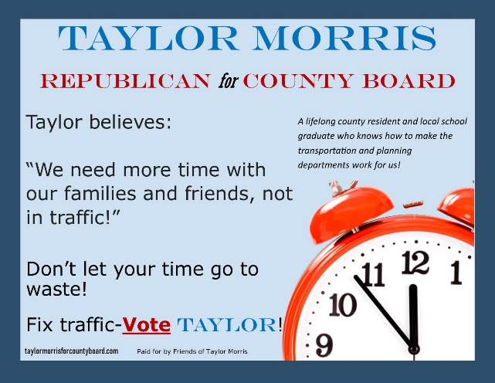 | 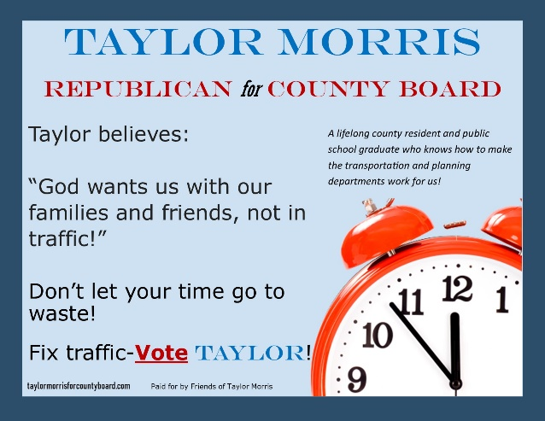
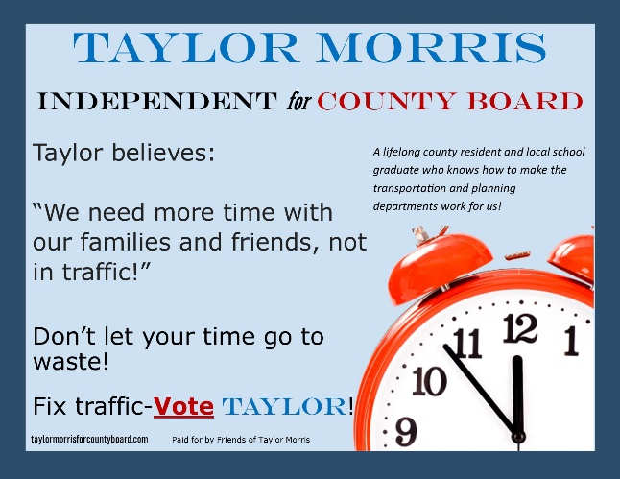 | 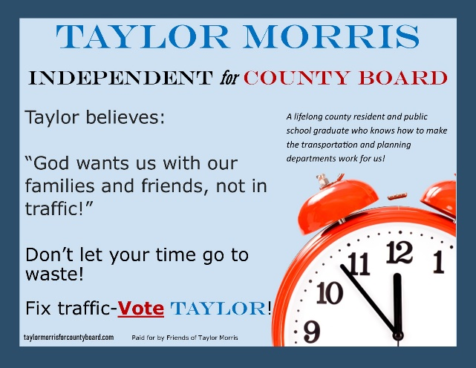
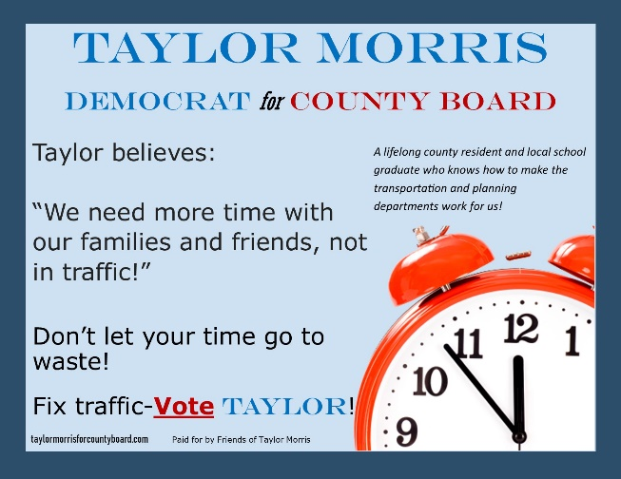 | 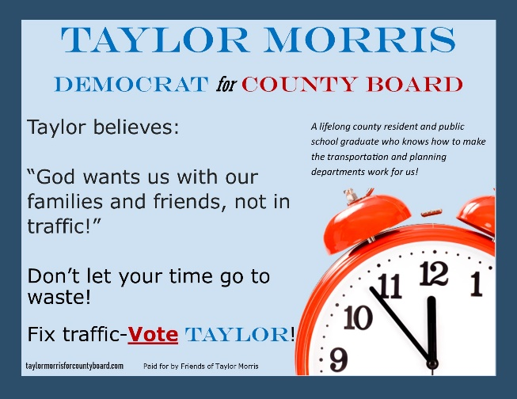

Control: Moralized | Treatment: Moralized
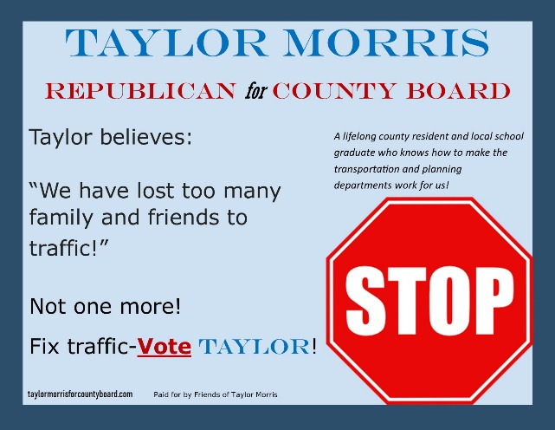 | 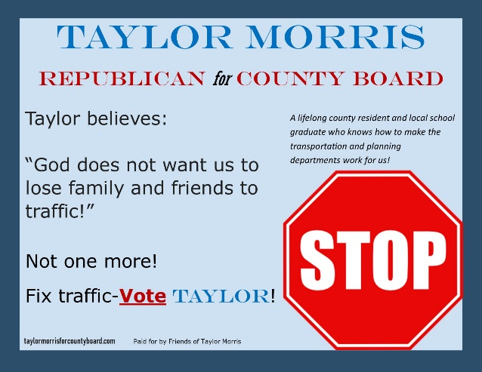
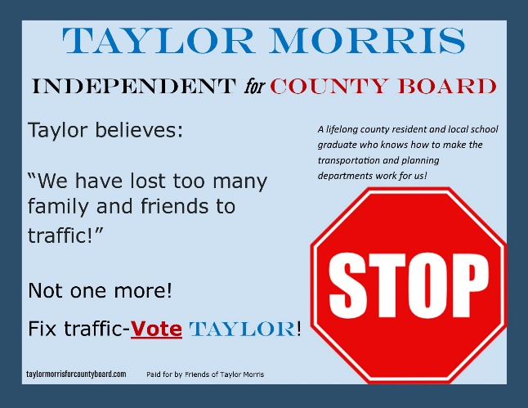 | 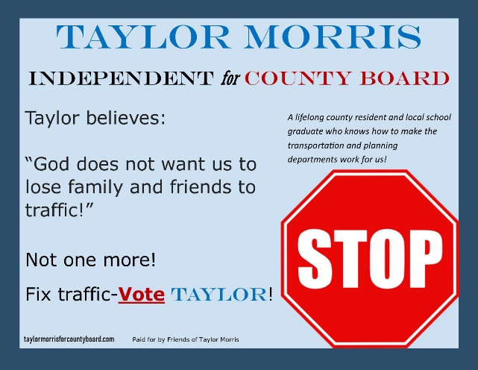

- Continue

Q10. Think back to the advertisement on the previous page. Assume you are eligible to vote in this election. Please indicate how much you agree with the following statements.
[PRESENT ON SCREEN IN GRID FORMAT – RADIAL BULLETS EVENLY SPACED, TEXT AS LISTED ABOVE 0 TO 4 AND NUMBERS ABOVE RADIAL BULLET FOR EACH NUMBER]
TEXT ABOVE RADIAL BULLETS  [RANDOMIZE ROWS] | Strongly disagree  0 | Somewhat disagree 1 | Neither disagree nor agree 2 | Somewhat agree 3 | Strongly agree 4
I would vote for this candidate (Taylor Morris).
Achieving the policy stated in the ad (solving traffic problems) is important to me.
My opinion on solving traffic problems is a reflection of my core moral beliefs and convictions.
My opinion on solving traffic problems is deeply connected to my fundamental beliefs about right and wrong.

Q11. Think back to the advertisement in Question 9. Assume you are eligible to vote in this election. Please indicate how much you agree with the following statements.
[PRESENT ON SCREEN IN GRID FORMAT – RADIAL BULLETS EVENLY SPACED, TEXT AS LISTED ABOVE 0 TO 4 AND NUMBERS ABOVE RADIAL BULLET FOR EACH NUMBER]
TEXT ABOVE RADIAL BULLETS  [RANDOMIZE ROWS] | Strongly disagree  0 | Somewhat disagree 1 | Neither disagree nor agree 2 | Somewhat agree 3 | Strongly agree 4
This candidate (Taylor Morris) is trustworthy.
This candidate (Taylor Morris) is primarily interested in power and money.
This candidate (Taylor Morris) is committed to achieving the policy stated in the ad (solving traffic problems).
This candidate (Taylor Morris) is likely to successfully solve the issue raised in the ad (solving traffic problems).
The candidate’s (Taylor Morris’s) opinion on solving traffic problems is a reflection of the candidate’s core moral beliefs and convictions.
The candidate’s (Taylor Morris’s) opinion on solving traffic problems is deeply connected to the candidate’s fundamental beliefs about right and wrong.

Q12. Think again back to the advertisement you read in Question 9. We’d like you to consider what you expect other people who might vote in an election to think of the candidate. Please indicate to what extent you agree with each of the following statements.
[PRESENT ON SCREEN IN GRID FORMAT – RADIAL BULLETS EVENLY SPACED, TEXT AS LISTED ABOVE 0 TO 4 AND NUMBERS ABOVE RADIAL BULLET FOR EACH NUMBER]
TEXT ABOVE RADIAL BULLETS  [RANDOMIZE ROWS] | Strongly disagree  0 | Somewhat disagree 1 | Neither disagree nor agree 2 | Somewhat agree 3 | Strongly agree 4
People like me are likely to vote for this candidate (Taylor Morris).
Achieving the policy stated in the ad (solving traffic problems) is important to people like me.
People like me are likely to believe this candidate (Taylor Morris) is trustworthy.
People like me are likely to believe the candidate (Taylor Morris) is likely to successfully solve the issue raised in the ad (solving traffic problems).
People like me are likely to believe the candidate (Taylor Morris) is committed to achieving the policy stated in the ad (solving traffic problems).
People like me are likely to believe that this candidate (Taylor Morris) is primarily interested in power and money.

Q13. Think again back to the advertisement you read in Question 9. We’d like you to further consider what you expect other people who might vote in an election to think of the candidate. Please indicate to what extent you agree with each of the following statements.
[PRESENT ON SCREEN IN GRID FORMAT – RADIAL BULLETS EVENLY SPACED, TEXT AS LISTED ABOVE 0 TO 4 AND NUMBERS ABOVE RADIAL BULLET FOR EACH NUMBER]
TEXT ABOVE RADIAL BULLETS  [RANDOMIZE ROWS] | Strongly disagree  0 | Somewhat disagree 1 | Neither disagree nor agree 2 | Somewhat agree 3 | Strongly agree 4
Religious people are likely to vote for this candidate (Taylor Morris).
Achieving the policy stated in the ad (solving traffic problems) is important to religious people.
Religious people are likely to believe this candidate (Taylor Morris) is trustworthy.
Religious people are likely to believe the candidate (Taylor Morris) is likely to successfully solve the issue raised in the ad (solving traffic problems).
Religious people are likely to believe the candidate (Taylor Morris) is committed to achieving the policy stated in the ad (solving traffic problems).
Religious people are likely to believe that this candidate (Taylor Morris) is primarily interested in power and money.

Identity

Q14. In terms of what’s important about you, how much do you identify as each of the following?

[PRESENT ON SCREEN IN GRID FORMAT – RADIAL BULLETS EVENLY SPACED, TEXT AS LISTED ABOVE 0 TO 10 AND NUMBERS ABOVE RADIAL BULLET FOR EACH NUMBER]
TEXT ABOVE RADIAL BULLETS  [RANDOMIZE ROWS] | Not at all  0 | 1 | 2 | 3 | 4 | 5 | 6 | 7 | 8 | 9 | Very Strongly  10
A citizen of the United States
A citizen of the world
A follower of your religious faith
A member of your race
Part of your ethnic group
Your gender

Q15. Which one of these identities is most important to you today? [RANDOMIZE]

Please select one.
- A citizen of the United States
- A citizen of the world
- A follower of your religious faith
- A member of your race
- Part of your ethnic group
- Your gender

Q16. Please rate your feeling toward the following groups in society. A score of one hundred means a very warm, favorable feeling toward the group; zero means a very cold, unfavorable feeling toward the group, and fifty means not particularly warm or cold. You can use any number from zero to one hundred, the higher the number the more favorable your feelings are toward that group. [RANDOMIZE ROWS; FOR EACH ROW, CREATE A SLIDER GIVING CHOICES 0 TO 100]

Republicans
Democrats
Nonreligious people
Evangelical Christians
Catholics
Jews
Muslims
Black or African Americans
White or Caucasian Americans
Hispanic or Latino Americans
Asian Americans
Feminists
Black Lives Matter
Born Again Christians

Other Demographics

Q17. We are going to ask a few questions about your background and your family. Remember, your responses are anonymous and you may skip a question at any time. Your background and your family have been shown by numerous studies to have an influence on your views about current events. We also want to know how closely you are reading the questions. To show you are reading the questions carefully, please ignore the question below and select both only child and one sister.

Which following statements applies to your family? You may select multiple choices. [Randomly reverse]

- I am an only child.
- I have one brother.
- I have two brothers.
- I have three or more brothers.
- I have one sister
- I have two sisters.
- I have three or more sisters.

Q18. Which of the following best describes your racial or ethnic background: [RANDOMIZE]

- Black or African American
- White or Caucasian American
- Hispanic or Latino American
- Asian American
- Multi-racial [FIXED]
- Other [FIXED]
Q19. Which of the following best describes you? [RANDOMIZE]
- Male
- Female
- Neither of these [FIXED]
- Prefer not to say [FIXED]

Q20. What is your religion? [RANDOMIZE]

- Evangelical Christian
- Catholic
- Ethiopian, Armenian, or Coptic Orthodox Christian or similar
- Greek, Russian, or Serbian Orthodox Christian or similar
- Protestant, but not Evangelical, Christian
- Jewish
- Mormon
- Muslim
- Sikh
- Hindu
- Other Christian [FIXED]
- Other Religion [FIXED]
- No Religion [FIXED]

Q21. Would you describe yourself as a born-again Christian? [RANDOMIZE]

- Yes
- No
Q22. How often do you attend religious services (other than for a wedding, a funeral, or similar personal event)? [RANDOMLY REVERSE]

- Never
- A few times a year or less
- About once a month
- A few times a month
- Weekly
- A few times a week
- Daily

Q23. How often do you pray? [RANDOMLY REVERSE]

- Never
- Once a month or less
- A few times a month
- A few times a week
- Once daily
- Two to four times daily
- 5 times daily or more often

Q24. How often do you use media for your religion, such as reading a social media account or news website, watching tv, or listening to radio aimed at your religion? [RANDOMLY REVERSE]

- Never
- A few times a year or less
- A few times a month
- A few times a week
- Daily or more

Q25. How often do you participate in a group activity, other than religious services, for your religious or spiritual development (such as volunteering for a religious purpose or studying scripture)? [RANDOMLY REVERSE]

- Never
- A few times a year or less
- A few times a month
- A few times a week
- Daily

Q25B. How important is religion in your life? [RANDOMLY REVERSE]

- Very important
- Somewhat important
- Slightly important
- Not very important
- Not at all important

Q26A. [ONLY ASK OF CHRISTIANS (I.E., RESPONDENTS WHO ANSWERED “Evangelical Christian”, “Catholic”, “Mormon”, “Other Christian”; “Pentecostal”; FOR THE RELIGION QUESTION OR WHO ANSWERED “Yes” to Q18] Which of the following statements comes closest to describing your views about the Bible? [RANDOMLY REVERSE]
- The Bible is the inspired word of God and is to be taken literally, word for word.
- The Bible is the inspired word of God, but not everything in it should be taken literally.
- The Bible is an ancient book of legends, history, and moral precepts recorded by humans.
Q26B. [ONLY ASK OF JEWS; THOSE WHO ANSWERED “No” in Q18] Which of the following statements comes closest to describing your views about the Torah: [RANDOMLY REVERSE]
- The Torah is the inspired word of God and is to be taken literally, word for word.
- The Torah is the inspired word of God but not everything in it should be taken literally.
- The Torah is an ancient book of legends, history, and moral precepts recorded by humans.
Q26C. [ONLY ASK OF THOSE WHO ANSWERED “No” in Q18 and “Muslim” in Q17] Which of the following statements comes closest to describing your views about the Qur’an: [RANDOMLY REVERSE]
- The Qur’an is the preserved speech of God and is to be taken literally, word for word.
- The Qur’an is the preserved speech of God, but not everything in it should be taken literally.
- The Qur’an is an ancient book of legends, history, and moral precepts recorded by humans.
Q26D. [ONLY ASK OF THOSE WHO ANSWERED “No” in Q17 and “Other Religion” or “No Religion” in Q16] Which of the following statements comes closest to describing your views about the Holy Scripture: [RANDOMLY REVERSE]
- The Holy Scripture is divinely inspired and is to be taken literally, word for word
- The Holy Scripture is divinely but not everything in it should be taken literally
- The Holy Scripture is ancient writing about legends, history, and moral precepts recorded by humans

Q27. Are you a US Citizen? [Randomly Reverse]

- Yes
- No

Q28. Are you registered to vote? [Randomly Reverse]

- Yes
- No

Q29. Have you voted in local elections (such as county board, city or town council, or school board) before? [Randomly Reverse]

- Yes
- No

Q30. Thinking of the candidate in Question 9 (Taylor Morris), how likely do you think it is that the candidate could be each of the following? [Randomize]

[PRESENT ON SCREEN IN GRID FORMAT – RADIAL BULLETS EVENLY SPACED, TEXT AS LISTED ABOVE 0 TO 4 AND NUMBERS ABOVE RADIAL BULLET FOR EACH NUMBER]
TEXT ABOVE RADIAL BULLETS  [RANDOMIZE ROWS] | Very unlikely  0 | Somewhat unlikely  1 | Neither unlikely nor likely  2 | Somewhat likely  3 | Very likely  4
Black or African American
White or Caucasian American
Hispanic or Latino American
A man
A woman

Q31. Thinking of the candidate in Question 9 (Taylor Morris), how likely do you think it is that the candidate could be each of the following? [Randomize]

[PRESENT ON SCREEN IN GRID FORMAT – RADIAL BULLETS EVENLY SPACED, TEXT AS LISTED ABOVE 0 TO 4 AND NUMBERS ABOVE RADIAL BULLET FOR EACH NUMBER]
TEXT ABOVE RADIAL BULLETS  [RANDOMIZE ROWS] | Very Unlikely  0 | Somewhat Unlikely  1 | Neither Unlikely nor Likely  2 | Somewhat Likely  3 | Very Likely  4
Evangelical Christian
Born Again Christian
Catholic
Mormon
Jewish
Muslim
Non-religious

Q32. Think back to the political advertisement you read earlier. Did the candidate in the ad reference God? [Randomly Reverse]

- Yes
- No

Q33. Just a few more questions. Remember that your answers are anonymous, and you may skip any question with which you are uncomfortable. To what extent do you agree with each of the following statements?
[PRESENT ON SCREEN IN GRID FORMAT – RADIAL BULLETS EVENLY SPACED, TEXT AS LISTED ABOVE 0 TO 4 AND NUMBERS ABOVE RADIAL BULLET FOR EACH NUMBER]
TEXT ABOVE RADIAL BULLETS  [RANDOMIZE ROWS] | Strongly disagree  0 | Somewhat disagree 1 | Neither disagree nor agree 2 | Somewhat agree 3 | Strongly agree 4
I am fearful of people of other races.
White people in the US have certain advantages because of the color of their skin.
Racial problems in the US are rare, isolated situations.
I am angry that racism exists.

Q33B. Are you currently enrolled in GVPT 200 Introduction to International Relations?
- Yes
- No

Q34. During this interview you were asked to read to a candidate’s campaign advertisement. This ad was not real. We created it in order to better understand how the justification a candidate gives for promoting a policy impacts voter’s support for and beliefs about candidates.
Please do not, therefore, base your own evaluations of policies, public officials, or candidates on the material you read in this study. Researching candidates, public officials, and public policy on your own via various information sources is the best way to make an informed choice. Finally, please do not share any information about this study with other students in the class.
We apologize for this deception as to the purpose of this study. If you would like to remove your data from the study, you may click withdraw below.
Here is your completion code [code]. Submit this code in the form attached to the sign-up email. If you do not submit this code, we are unable to verify your participation.
These are all the questions we have for you. Thank you for your time and should you have questions, please contact:
Sean Rao
3140 Tydings Hall
7343 Preinkert Drive
College Park, MD 20742
(301) 405-4156
Email: seanrao@umd.edu
- Yes, I consent and submit the anonymous survey results.
- No, I would like to withdraw consent and remove survey data.

[Questionnaire included a progress bar.]

