Praying Together and Staying Together: Faction Survival in Self-Determination Movements

Sean Rao

September 9, 2022

University of Maryland

Abstract: Why do some organizations persist in demanding autonomy or independence for decades while others cease after only a short time? Research on civil war duration has rarely been linked with research on the duration of other strategies of contention, and little is known about the persistence of contentious actors who may or may not become later rebels. The persistence of demand making organizations is an understudied, underlying factor in the study of contentious strategies and civil war duration. I argue that the persistence of organizations’ demands is primarily a function of membership continuity, and that organizations which base their political claims in religion or religion-like ideologies are likely to have more committed members and, ultimately, persist in making demands than other organizations. I test this on a novel cross-national time series dataset of organizations within self-determination movements. I classify each organization in the dataset by whether it has a religion or religion-like ideology as the foundation of its political goals, not merely as an identity, and whether it requires public commitment among the members, such as religious study or dress codes, as membership practices. I find evidence that religious organizations and those with religion-like ideology are more likely to persist compared to nonreligious organizations. Additionally, organizations which encourage membership practices demonstrating public commitment do so as well. Thus, both religion and behavioral incentives sometimes associated with religion facilitate the persistence of demands by self-determination organizations, revealing a new mechanism linking religion and contentious action, including civil war duration.

Introduction
Why do some organizations persist in demanding autonomy or independence for decades while others persist in making such demands for only a short time? Many ethnic groups seek self-determination from states, but these movements are not unitary, consisting of many specific organizational actors (Cunningham, Bakke, Seymour 2012). Some of these organizations persist for decades, while others arise among an ethnic group which is already represented by existing organizations only to quickly fade from the scene, leaving others to continue the movement. Consider that organizations demanding self-determination for the Afar in Ethiopia have persisted from 1974 to the present day. The Liberation Movement of the Afars has been active in demanding self-determination for the Afar for this entire period. By contrast, another Afar organization demanding self-determination, the Afar National Democratic Movement, was only active between 1994 and 1999. Any actor in a dispute could potentially veto a bargain between the state and the self-determination movement, provided their preferences were distinct from the others (Cunningham 2011, 33, 44). Moreover, the more extreme the demands of each actor, the more likely war is to break out; moderation in organizations’ demands, by contrast, makes a peaceful resolution more likely (Jenne 2004). So, the persistence of organizations as potential veto-players and of their demands as potential limits on bargains should substantially increase the likelihood of conflict. Yet, what explains such a variation in the ability of each organization to persist in making demands against the government?

I argue that the rhetorical basis of an organization’s political claims as well as the ideas that strengthen ties between an organization’s members and leadership grant an organization the cohesion needed to persist over time. Particularly, I further argue that organizations which derive their demands from religion or a strong, religion-like ideology enjoy an advantage in mobilization. These organizations often have membership standards which set behavior and encourage participation in nonpolitical activities which organizations expect their members to uphold. These allow members of each organization to signal their commitment to each other, granting an advantage in recruiting and retaining specific individuals through the production of solidary goods. This mechanism has been demonstrated for violent mobilization in a limited number of cases (Berman 2009) but has not been linked to the mobilization needs of different tactics of resistance broadly. Moreover, self-determination organizations vary substantially on whether or not they make their demands based in religion. For example, the Liberation Movement of the Afars adhered to an Islamist ideology for most of its existence, while the Afar National Democratic Movement never adhered to any religious or similar ideology.

Using a novel dataset on the demands and membership practices of organizations in self-determination movements. I find some evidence that organizations which derive their demands against the state from primarily from religion or a religion-like ideology alone are less likely to cease making demands in any given year. I find even stronger support for the role played by standards of behavior and participation in nonpolitical activities, which I argue serve as a commitment mechanism. Though associated with religious demands, these are practices are conceptually different (Berman and Laitin 2008, 1950): whether a demand is derived from religion is a purely ideational characteristic of the demand itself, while membership practices, even just the studying of religious ideas, involve some concrete, nonpolitical, action performed by the members. The results show that religion and ideology affect the persistence of the ability of an organization to make demands, regardless of whether that organization chooses violence or not. The results also show that specific signals of commitment, sometimes associated with religion but conceptually different from belief itself, additionally matter for mobilization.

Organizational Persistence
Most research of organizational survival or persistence has centered on violent organizations – either “rebels” or “terrorists.” Research on the duration of intrastate conflict has become increasingly precise in identifying actors involved. While some research provided insights through the study of state-level characteristics (Buhaug, Gates, and Lujala 2009), Cunningham, Gleditsch, and Salehyan (2009), argued the need to study the particular rebel organizations involved in conflict. This was a key insight as conflict is inherently an interaction between the government and specific rebel organizations, such that civil wars contain “a set of actors that have separate preferences over the outcome of the conflict and separate abilities to block an end to the war” Cunningham (2015, 15). Any rebel organization can be a spoiler; thus, the persistence of war is inherently linked to the persistence of the violent actors in the dispute.
Alongside this study of civil war duration has arisen a body of research studying other varieties of contention over such disputes, particularly with the development of the NAVCO dataset (Chenoweth and Lewis 2013). Many studies have brought attention to the choice that non-state actors face in opposing states: violence is merely one tactic out of several tactics available, such as nonviolent resistance (Cunningham 2013). A smaller amount of these have analyzed the organization level (Asal et al. 2013; Cunningham, Dahl, and Frugé 2017; Dahl et al. 2020). However, unlike in the civil war literature, very little is known about duration in nonviolent campaigns, an exception being Abbs and Gleditsch (2021), who find that the outbreak of riots puts an end to nonviolent campaigns. Yet, why specific organizations persist in their membership and demands remains unknown. Answering why organizations persist will inform duration of the possible set of contentious actors and the choice to engage in violence among that subset of these actors who make that choice.
This need to study potential, not just actual, violent actors, is indicated by a body of research on the actors which precede intrastate conflict. For example, Breslawski and Ives (2018) study how organizations making self-determination demands choose to engage in violence. White et al. (2015) argue that intrastate conflict is predicated on the pre- existence of demands against the state. These works suggest that intrastate conflict is preceded by organizations and demands. If this is so, it implies a need to explain why organizations and demands vary so much in their persistence and, therefore, in their ability to create the underlying conditions for further contentious action.
I answer why some organizations persist in their membership and demands while others disappear quickly by studying how religion affects the cohesion of membership in political organizations. Religious demands not only increase the intensity of violence in conflicts (Svensson and Nilsson 2018; Toft 2021) but also mobilize individuals who are less willing to compromise. Thus, organizations with religious demands are less willing to accept concessions because of the distinct characteristics of their memberships, increasing conflict duration (Keels and Wiegand 2020). Since religious demands recruit a membership less willing to compromise and, therefore, may prolong war, the membership of an organization pursuing religious demands may similarly persist in demand making, regardless of the presence of conflict. Yet, it is important to test this directly. As long as religious demands are only studied in the violent context, it is not possible to separate religious demands in general from religious demands that may develop in the runup to conflict itself. The factors that created the violent situation could also have created the religious claims (Maoz and Henderson 2020, 375, 381). This means that the study of religious claims on the persistence of demands, encompassing both violent and nonviolent conditions, is distinct from the study of religious claims only within existing violence; we lack knowledge on religion in organizations that make demands of the government but do not choose to go to war.
I study self-determination organizations to study an appropriate set of demand-making organizations which are not limited to intrastate conflict or any other particular tactic, permitting the study of the effect of religion on the persistence of organizations themselves and their political demands, rather than the persistence or intensity of violence. I use the set of self-determination organizations from Cunningham (2014). As in the case of the Afar above, they vary greatly in their religious affiliations and persistence, and are selected based on their participation in self-determination disputes, not any particular tactic, making them a good sample on which to study the question. Despite this, the organizations often do use violence, as well as nonviolent tactics (Cunningham, Dahl, and Frugé 2017), making them a substantively interesting category for the study of both civil war and nonviolent contention.
The question of organizational persistence in self-determination movements thus makes an important contribution to the study of civil war persistence, even though it does not itself ask about violent activity. Answering this question adds to the longstanding need to know more about rebel organizations, not just civil wars at the conflict or country level (Cunningham, Gleditsch, and Salehyan 2009) and the need to understand civil war as just one tactical choice out of several by which an organization may pursue a demand against the government (Cunningham 2013). The individuals mobilized by religious demands can cause civil war to persist longer due to their uncompromising stances (Keels and Wiegand 2020), but religious demands after war has begun are not necessarily the same as those existing before the war (Maoz and Henderson 2020, 375, 381). Therefore, the impact of religious cohesion on the persistence of membership and demands in a set of the organizations which could have gone to war but may or may not have chosen to do so is a highly relevant question to the study of intrastate conflict and contentious action. This article furthers the study of civil war duration, first, by measuring an understudied factor which underlies it, the persistence of organizations which may or may not rebel, and, second, by examining the influence of religion, on the organizational cohesion of these organizations over time without limiting religion to beliefs held after the outbreak of violence.

Theory
I make several assumptions about the nature of political activity and mobilization in order to hypothesize the relationship between religion and organizational duration. First, each organization has a leadership, which claims to represent a set of constituents and demands concessions from the government regarding autonomy or independence. Second, each organization attempts to impose costs on the government in order to make the government prefer a concession to the status quo. Third, the leadership needs some group of constituents to actively participate to impose these costs on the government. Other resources, particularly money, may be useful, even necessary, but remain insufficient without people to use them. This is true whether the tactics are violent, nonviolent, or even conventionally imposed through legal electoral activity. So, any organization requires participants to persist in pursuit of its demands. To do this, an organization needs to maintain greater expected benefits than expected costs for participants in activities against the government (Weinstein 2007, 7-8; Gates and Nordås 2010, 7).
I argue that an organization whose goals are religiously motivated can increase the expected value of participation among those who share the same beliefs because of the potential to generate rewards based on those beliefs (Gates and Nordås 2010, 3; Walter 2017, 9, 20). Religion can provide a shared, systemic understanding of daily emotions, establishing a relation between the people experiencing the emotion and other people whose are supposedly at fault (Costalli and Ruggeri 2015, 127-8). When this understanding derives from “an exogenous principle (ideology, ideal, doctrine, deity)” which is often “interpreted, administered, maintained, or even personified” by the organization’s leadership, recruits receive utility, “functional rewards”, from participating in the just cause of the organization (Gates and Nordås 2010, 9, 28), regardless of the eventual outcome of the participation. This increases the value of participation at low cost to the organization (Walter 2017, 20). Since functional rewards can be generated indefinitely, religion can facilitate the recruitment and retention of devotees over time and, ultimately, the persistence of the organization and its demands.
Yet, religion may also impose costs on potential recruits. Only a particular subset of the population may sufficiently accept the religious beliefs of the organization to receive functional rewards from participation; other parts of the population may have somewhat different religious preferences (Walter 2017, 17-8). Such individuals may be somewhat discouraged from supporting the organization (Szekely 2014, 282). Assuming that constituents naturally vary in their propensity to accept the beliefs of the organization, functional rewards mainly facilitate participation among a particular subset of the constituency. So, if this were the only mechanism for religious organizations to increase mobilization, the ultimate impact on an organization’s persistent ability to pursue demands against the government would be limited.
There is, however, another way for religious organizations to facilitate mobilization and ability to persist in demand-making, though marketing and using religion as a commitment signal. Beyond those constituents inclined to fully accept the beliefs of the organization, other constituents may not accept those beliefs or do so only weakly. Being constituents of the self-determination movement, may still care about the shared goals of the movement. So, they could be convinced to participate in the tactics of the organization, provided they believe the organization to be capable of success and sincere in its ability to successfully put costs on the government, fulfill their promises, reject unfavorable bargains, and avoid pecuniary monetary gain or power for its own sake. This may be particularly true in violent conflicts (Walter 2017, 17), but even in a solely nonviolent movement, constituents should still prefer organizations which intend to fulfill the shared goals of the movement to those who organizations whose leaders primarily care about power-seeking and graft.
Religious organizations may be such organizations because those unaffiliated constituents who do not fully accept the beliefs of the organization receive information from the recruitment of those constituents who do. When an organization recruits highly committed constituents and carries out tactics with them, this signals to unaffiliated constituents that the organization has at least a minimal capability to mobilize. When organizations demonstrate that they have highly committed participants, unaffiliated constituents are more likely to perceive that they are capable and sincere (Walter 2017, 11-2, 30).
The ability to recruit for particular tactics beyond those willing to directly accept the beliefs of the organization is possible through marketing. Organizations can frame themselves as benefiting a constituency wider than their core. This is possible by demonstrating their performance and gaining attention by mobilizing their core supporters. With enough attention, the organization can position itself as the obvious choice for the broader constituents to support (Szekely 2011, 28-35). Thus, the mechanisms normalizing costly participation and prohibition facilitate recruitment only among a subset of the constituency, but when marketed, an organization can use its core recruits to recruit a broader set of constituents for contentious tactics.
This marketing is available to organizations whose demands are made in the context of religion. These beliefs permit the generation of functional rewards to a subset of committed believers. The increased ability to mobilize this set of constituents suggests commitment and capability to other constituents. When this commitment and capability are marketed to the broader group of constituents, the organization can signal that participation in its activities has a greater expected value than those of an organization whose demands are not based in such beliefs. Therefore, religious organizations should be better able to mobilize constituents, increasing those organizations’ ability to persist in making demands against the government.
In addition to religion itself, functional rewards and marketing can also be derived from religion-like ideologies. Theology can serve as a common “programmatic orientation,” which but it is not the only possible theme (Schubiger and Zelina 2017, 948) which can arrange political ideas into a set (Ugarriza and Craig 2012, 450; Gutiérrez-Sanín and Wood 2014, 215). An ideology can be a “way of understanding the world”, using “doctrines, narratives, symbols, and myths” to outline “relations between members of a group and outsiders, and among members” of the group (Ugarriza and Craig 2012, 450) and can relate them to a political grievance, define goals to rectify these grievances (Costalli and Ruggeri 2015, 127; Gutiérrez-Sanín and Wood 2014, 215; Ahmadov and Hughes 2017, 3), and define, to some extent, action to reach these goals (Gutiérrez-Sanín and Wood 2014, 215; Ugarriza and Craig 2012, 451). Therefore, there can be ideologies which function similarly to religion, though they are not religious: for example, certain socialist organizations which ascribe to their leadership a vanguard role can feature strong internal discipline based on belief in socialist ideology (Kalyvas and Balcells 2010, 421) similar to religious moral authority among religious organizations. Marxist organizations like Peru’s Shining Path (Sendero Luminoso) (Gutierrez Sanín and Wood 2014, 218, 221) or the Communist Party of Bangladesh provide striking examples. Thus, I refer to such ideologies as religion-like ideologies and consider them similar to religion for purposes of this research.
Hypothesis 1: Religious organizations (and those with similar ideologies) can persist in making political demands for longer than organizations which lack such beliefs.
Religious organizations can generate functional rewards among dedicated believers and signal commitment and capability to a broader set of constituents; they can increase this signal further the greater the visible commitment among the existing members. Thus, religious organizations may enjoy a recruitment and retention advantage because they can normalize costly participation in the organization’s activity among its members. Participation in costly, time-consuming activities, such as religious study and charitable work, signals the members’ willingness to commit to the organization, which deters free riders and assures members that other members will contribute to the organization (Berman 2000, 905-6; Iannaccone and Berman 2006, 116; Berman and Laitin 2008, 1943; Berman 2009, 22). Together, by enduring time-consuming activities, members create confidence in each other that they will not defect from the organization. This is visible to a substantial number of members, and so, generates the expectation that everyone will participate: this expectation creates incentives for all members to remain loyal to the organization (McLauchlin 2010, 333, 338-9). This creates a belief among potential recruits that they will not be alone if they participate in the organization’s tactics.
Because the members of the organization are committed to each other, they have an advantage at “cooperative production” (Iannaccone and Berman 2006, 125). Such organizations can provide club goods, particularly, mutual social aid (Berman 2000, 908; Berman and Laitin 2008, 1942; Berman 2009, 21). This advantage at cooperative production increases the advantage of joining to potential recruits, and since they may find the club goods useful, reduces their incentive to desert leading to higher retention (McLauchlin 2014, 1437).
Religious organizations may enjoy a further retention advantage when their beliefs normalize costly prohibitions of particular social or economic activities outside the organization. Observing each other obeying prohibitions further strengthens the confidence members have in each other’s commitment to the organization (Iannaccone and Berman 2006, 116, 125). Additionally, costly prohibitions on outside activities make engaging in activity outside the organization harder. This increases the value of participating in the organization, particularly the value of the social aid and other club goods provided by the organization, because members have difficulty obtaining similar goods and social aid outside the organization (Berman 2000, 908; Iannaccone and Berman 2006, 116; Berman and Laitin 2008, 1943, 1951). Hence, the normalization of costly prohibitions makes it even less likely that members have the opportunity to desert the organization, either to another organization, to the government, or to inactivity, further ensuring retention of participants in the organization.
Norms of costly participation and prohibition strengthen the credibility of organization leaders, as well. By following the prohibitions and enduring the required sacrifices of participation, the organization’s leaders demonstrate their commitment to the rank-and-file (Iannaccone and Berman 2006, 125). This demonstrates that the that they are not primarily engaged in politics for graft or power for its own sake. Moreover, such leaders, being dedicated to their political goals, are less likely to be bought off by the government through deals which serve them personally but harm the constituents they claim to represent (Walter 2017, 23-5). This further increases the expected value of participation in both the short and long-run, further facilitating recruitment and retention.
The normalization of costly participation in the organization and costly prohibition of activity outside the organization ties people so closely to the club goods, particularly social aid, provided by the organization and its leadership, that members perceive a social benefit from furthering the cause of the organization for its own sake. This further increases the marketing effect as well, as the members of the organization are visibly committed to each other and, thus, can be seen as more capable and sincere. Therefore, visible norms of costly participation and prohibition, even though they impose costs on participants, should increase the expected benefit of participation in an organization’s activities. This means that religious organizations which visibly adhere to these norms should enjoy an advantage in mobilization and retention and, thus, be more able to continue to pursue demands against the government.
As with Hypothesis 1, membership practices may derive from religion-like ideology as well as from religion itself. Costly participation and prohibition often draw on the moral authority of religion (Berman 2009), and small, strict sects like the Haredi Jews often exhibit particularly strong and visible membership practices. Still, more widespread religions exhibit them to an extent, and membership practices do not necessarily require a theological basis (Iannaccone and Berman 2006, 117). Therefore, I again refer to religion-like ideologies that have provide a systemic basis for thought upon which membership practices can be based in addition to religion itself.
Hypothesis 2: Religious organizations (and those with similar ideologies) which encourage norms of costly participation or prohibition can persist in making political demands for longer than organizations which lack such norms.

Research Design
I test these hypotheses with a novel data set. The ideal set of cases is a set of political movements which are making costly demands upon the government. Demands for autonomy or independence impose high costs upon a government because they limit a state’s sovereignty in part or in full. However, these hypotheses do not depend on the use of a particular tactic, such as insurgency or terrorism, but nearly all such lists of dissident organizations are generated by the tactics chosen; for example, organizations engaging in civil war (Sundberg and Melander 2013) or terrorism (START 2018; Heger and Jung 2017). To avoid this limitation, I build this dataset on Cunningham’s (2014, 14; 235) list of self-determination movements, which are ultimately drawn from a list of the Minorities at Risk project (Marshall and Gurr 2003), and studied between 1960 and 2016. The full set consists of 1124 organizations making claims for self-governance on behalf of 138 identity groups; however, due to the practical difficulties of coding this number of organizations, I have created my dataset on a subset of 51 organizations in 5 randomly selected identity groups in Pakistan, India, Canada, and Ethiopia; this leads to an organization-year sample of 850 observations.
For each organization, I code whether it is a religious organization (or following a religion-like ideology). Recall that for members to receive a benefit solely for pursuing the organization’s cause, its claims must be on behalf of the religion or ideology (Gates and Nordås 2010, 9, 28; Walter 2017, 20). Crucially, an organization whose membership happens to adhere to a particular religion would not enjoy this effect unless its claims were based on that belief. So, this coding expressly does not include organizations that may discuss religion occasionally as a means of carrying out other goals (like the Palestinian Liberation Organization, for example) or nonreligious organizations that are associated with a religious identity group despite being themselves nonreligious (like the Irish Republican Army, for example). I have only coded as religious an organization whose primary political claims are considered, at least in public, by an organization to be a necessary result of pursuing a religion or religion-like ideology in each year in which the organization is active.
For each year in which an organization has been actively pursuing self-determination demands, I have coded whether religion or a religion-like ideology primarily motivated those demands within the organization. An organization is coded as religious in a year when it has a primary justification for its core political claims and that justification consists of a system of thought which the same organization considers to exclusively direct at least some behavior outside of the context of the political dispute with the government. While such systems of thought are usually religious, they do not have to be (Berman and Laitin 2008, 1950), with socialist ideology sometimes providing a similar function (Kalyvas and Balcells 2010, 421). Such principles are not necessarily a closed set. In the current sample, the nonreligious ideologies that meet this requirement are socialism and indigenous knowledge, by which I mean the extension of cultural tradition to a comprehensive system of thought which is used to derive rules for new social situations. For example, the Inuit Circumpolar Conference used “traditional indigenous discourse (stewardship, subsistence, traditional knowledge, and indigenous governance) and transformed these into an overarching contemporary Arctic political agenda” (Shadian 2006, 284). Since the organization uses this as a system of thought which directs ecology as well as politics, it meets the above definition of a religion-like ideology.
I have also coded a binary indicator for the whether or not organization has encouraged its members to engage in participation in non-political activities or uphold standards of behavior, either of which constitutes a signal of commitment among the members to each other. Costly participation involves theoretical religious or ideological activities, such as worship or education, labor to provide services not directly related to tactics, or very time-consuming social events. This indicator is present in a year when one of several such signals is present. First, the organization may have encouraged members to engage in time-consuming activities with each other: for example, members of the Bodo Sahitya Sahba annually commemorate the foundation of the organization with a special ceremony (BSS 2004) and are encouraged to organize and participate in dance, music, and art festivals which promote the culture of the self-determination group (Saika 2009, 116-7). For the commitment to be credible, this commitment must be visible to the membership at large (Berman 2009, McLauchlin 2015, 669), so only those activities which the membership at large has the opportunity to witness will count. Furthermore, to avoid endogeneity, activities directly related to pursuing political activity: the direct training, planning, or carrying out of tactics, or obtaining material resources for the same will not be counted as costly ideological participation. (Moreover, these are not as costly of signals of commitment to the cause since they also further an individual’s chances at rising in power in the organization from taking successful action against the state.).
Second, signals of commitment also include costly prohibitions, the second factor which facilitates the production of club goods and, ultimately, recruitment, for each organization. More broadly, these are mandates on behavior which reduce options to receive club goods outside of the organization by visibly distinguishing the members from the general public (Berman 2000, 908; Iannaccone and Berman 2006, 116; Berman and Laitin 2008, 1943, 1951). Examples include mandates about diet, clothing, social activities, particularly those related to family and children, travel, and media consumption; all of these distinguish organization members and make it more difficult for them to find solidary goods and social services from other parts of society (Berman 2009, 65, 80).
The coding process for each organization and variable was carefully structured to be consistent across observations. I searched the sources used to build the Cunningham’s (2014) dataset: Lexis Nexis, Factiva, Keesing’s news databases, as well as searching dissertations, academic books, and articles. After searching these, I employed searches in Google for additional sources if needed. I first looked for an organization’s demands for independence, autonomy, or other rights for the identity group. I looked to see if an organization’s highest demand-- i.e., independence if applicable, then autonomy, and only other demands for the identity group’s self-governance (such as land rights) if neither independence or autonomy was demanded—was justified as part of religious framework or another framework of ideas. If another framework, it needed to assert that that framework explained behavior outside the political context against the government. If an organization made a demand against the government or used a religious justification at a point in time, I considered that situation to have continued until and unless, either it was clearly linked to a one-time event, or I found later evidence that the organization had ceased to make that demand or use that justification. I coded costly participation and prohibitions similarly, except that I only considered these to have continued over time if there was evidence that the participation or prohibition was clearly intended to persist indefinitely; otherwise, I only coded these in the years for which I found direct evidence for them. An organization did not have to have a religious or religion-like ideology to require costly participation and prohibitions, so these are potentially independent of the religion or religion-like ideology. Thus, this process provides a systemic review of an organization’s demands, systems of thought, and commitment signals for each year during which the organization made a demand on behalf of the identity group.
The sample of 51 organizations and 925 organization-years yields a distribution of five religious categories (Table 1). More than half (548 or 59 percent) of the organization-years are neither religious nor have any religion-like ideology. There are 52 (or 5%) socialist organization-years and 70 (8%) organization-years have an indigenous ideology. Given the sample, the religions involved are Hindu (231 organization-years or 25%) and Muslim (24 organization years or 3%). Thus, though the random sample is limited, it includes organizations both nonreligious and religious, from multiple religious families, as well as multiple religion-like ideologies.
Table 1: Distribution of Organization-Years by Religion or Ideology
 | None | Hindu | Islam | Socialist | Indigenous
Organization-Years | 548 | 231 | 24 | 52 | 70
Percent | 59.243 | 24.973 | 2.595 | 5.622 | 7.568

Table 2: Distribution of Organization-Years by Religion and Membership Practices
 | No Membership Practices |  | Membership Practices
 | Count | % of Religion | Count | % of Religion
None | 251 | 45.803 | 297 | 54.197
Hindu | 18 | 7.792 | 213 | 92.208
Islam | 1 | 4.167 | 23 | 95.833
Socialist | 51 | 98.077 | 1 | 1.923
Indigenous | 0 | 0 | 70 | 100

There is a similar variety of membership practices in the sample (Table 2). About half (54 percent) of nonreligious organization-years nevertheless have membership practices, while only 2 percent of socialist organization-years. Nearly all Hindu, Muslim, and indigenous ideology organization-years, by contrast, do feature membership practices.
Table 3: Distribution of Organization-Years by Type of Membership Practice
 | Education | Services | Clothing | Other Participation | Economic | Social
None | 157 | 5 | 19 | 60 | 6 | 195
Hindu | 133 | 175 | 112 | 161 | 121 | 179
Islam | 0 | 0 | 0 | 0 | 23 | 23
Socialist | 0 | 0 | 1 | 0 | 0 | 1
Indigenous | 70 | 0 | 0 | 0 | 0 | 0
Total | 360 | 180 | 132 | 221 | 150 | 398

The membership practices in the sample include all of the six categories described above (Table 3). Organization-years with religion-like ideologies are less likely to feature membership practices, but there are many nonreligious organization-years which feature them, particularly in education and social standards of behavior. The Hindu organization-years in the sample include many membership practices, but the Muslim ones primarily feature economic and social standards rather than clothing restrictions or requirements to provide social services or study particular forms of thought.
Table 4: Distribution of Country-Years by Decade
 | None |  | Hindu |  | Islam |  | Socialist |  | Indigenous
 | Count | % of Decade | Count | % of Decade | Count | % of Decade | Count | % of Decade | Count | % of Decade
1960s | 23 | 50 | 10 | 21.739 | 0 | 0 | 13 | 28.261 | 0 | 0
1970s | 46 | 66.667 | 10 | 14.493 | 4 | 5.797 | 6 | 8.696 | 3 | 4.348
1980s | 57 | 51.351 | 24 | 21.622 | 10 | 9.009 | 7 | 6.306 | 13 | 11.712
1990s | 129 | 60.563 | 42 | 19.718 | 10 | 4.695 | 12 | 5.634 | 20 | 9.39
2000s | 171 | 61.071 | 75 | 26.786 | 0 | 0 | 14 | 5 | 20 | 7.143
2010s | 122 | 59.223 | 70 | 33.981 | 0 | 0 | 0 | 0 | 14 | 6.796

Finally, there are a few patterns of religion over time in the sample (Table 4). Socialism declines as a proportion of organization-years over the course of the time period. Nonreligious organizations are more common after 1990 than before. Muslim and Indigenous organizations are most common in the 1980s, but Hindu organizations show no clear pattern over time.
In general, there is a lot of persistence in the data. Most organization-years persist into the next year. In 21 organization-years (2.270 percent), the organization ceases activity and fails to persist to the next year. Also, 30 organizations (3.243 percent) which remained active in 2016 are right-censored.
On this data, I estimate logistic regression models estimating the likelihood of an organization ceasing to make claims in a given year. Because it is reasonable to assume that an organization which has persisted many years is more likely to persist into the next year than a new organization, I control for the number of years that the organization has been actively making claims up to the year of observation in all models. Because states with civil liberties and greater wealth could, potentially, be more favorable environments for organizational persistence as well as the free practice of religion, I additionally estimate models with controls at the country level for liberal democracy (Coppedge et al. 2017, 51) from the Varieties of Democracy (V-DEM) project (Coppedge et al. 2017) and GDP per capita from the Penn World Table Version 10 (Feenstra, Inklaar, and Timmer 2015). All these variables are lagged by one year.

Results
As outlined above, Hypothesis 1 predicts that an organization which adheres to religion, or a religion-like ideology will be more likely to persist than other organizations. So, in a given year, I expect that the likelihood of a religious or similar organization ceasing to operate in the next year will be less than an organization which lacks religion or religion-like ideology. I start by estimating a model controlling solely for the age of an organization (Column 1 in Table 6 below). Model 1 shows that religious organizations and those with religion-like ideology are significantly have a significantly smaller log-likelihood of ceasing to persist into the next year compared to nonreligious organizations. This demonstrates strong evidence in favor of Hypothesis 1. Similarly, Model 1 shows additional evidence in favor of Hypothesis 1 when calculating predicted probabilities. The predicted probability of ending activity in the following year is .029 less for religious organizations and those with religion-like ideology than for nonreligious organizations (Figure 1 and Row 1 in Table 5 below). This is a substantively significant decrease as the baseline probability of ceasing activity (the proportion of organization-years that fail to persist) is .023. Therefore, Model 1 shows substantial support for Hypothesis 1 that religious organizations and those with religion-like ideology are more likely to persist than other organizations.

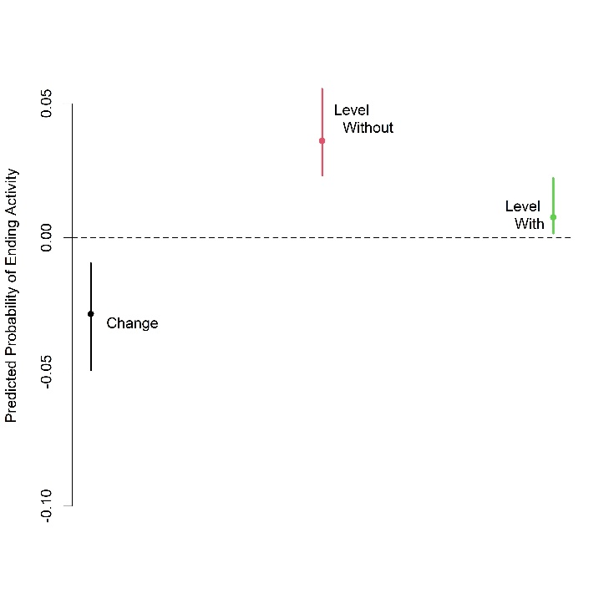
Figure 1: Probability of Ending Activity due to Religion (Model 1 - Religion Only)
Next, I turn to Hypothesis 2. Are organizations which promote membership practices less likely to cease activity in a year? In Model 2 (Column 2 in Table 6 below), I estimate a relationship between membership practices and the likelihood of ceasing activity in a year, controlling only for the age of the organization. As with Hypothesis 1, I find support for Hypothesis 2: organizations which promote membership practices have a significantly smaller likelihood of ceasing activity in a year compared to those organizations which do not have such practices. This corresponds to a .04 reduction in the predicted probability of ceasing activity in a year (Figure 2 and Row 2 in Table 5 below). Thus, as with Hypothesis 1, I find strong support for Hypothesis 2 that membership practices are associated with greater persistence.
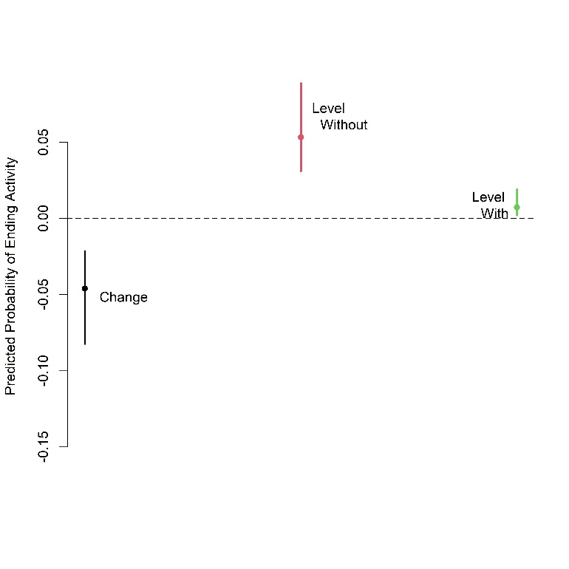
Figure 2: Probability of Ending Activity due to Membership Practices (Model 2 – Practices Only)

Table 5: Change in the Predicted Probability of Ending Activity in the Year due to Religion and Membership Practices

Model | Ideology | Signals | Change | 95% C.I. Min | 95% C.I. Max
M1: Religion Alone | 0 to 1 | NA | -0.029 | -0.051 | -0.008
M2: Membership Practices Alone | NA | 0 to 1 | -0.047 | -0.083 | -0.024
M3: Religion with Controls | 0 to 1 | NA | -0.032 | -0.053 | -0.011
M4: Membership Practices with Controls | NA | 0 to 1 | -0.045 | -0.082 | -0.020
M5: Both | 0 to 1 | Observed | -0.021 | -0.042 | 0.001
M5: Both | Observed | 0 to 1 | -0.039 | -0.068 | -0.015
M6: Both with Controls | 0 to 1 | Observed | -0.024 | -0.044 | 0.001
M6: Both with Controls | Observed | 0 to 1 | -0.035 | -0.067 | -0.011

Table 6: Logistic Regression Coefficients
 | Dependent Variable: Likelihood of Ending Activity in the Year
 | Religion Alone | Membership Practices Alone | Religion with Controls | Membership Practices with Controls | Both | Both with Controls
 | (1) | (2) | (3) | (4) | (5) | (6)
Religion | -1.819* |  | -1.928* |  | -1.344⁺ | -1.519*
 | (0.748) |  | (0.754) |  | (0.761) | (0.774)
Membership Practices |  | -2.238*** |  | -2.129** | -1.945** | -1.773**
 |  | (0.653) |  | (0.659) | (0.659) | (0.660)
Democracy (lag) |  |  | -2.140⁺ | -0.817 |  | -1.424
 |  |  | (1.245) | (1.170) |  | (1.281)
GDP per Capita (nat log, lag) |  |  | 0.043 | -0.058 |  | -0.002
 |  |  | (0.265) | (0.291) |  | (0.288)
Years of Activity | -0.057* | -0.029 | -0.060* | -0.030 | -0.031 | -0.038
 | (0.025) | (0.026) | (0.027) | (0.027) | (0.026) | (0.028)
Intercept | -2.639*** | -2.543*** | -1.333⁺ | -2.014** | -2.329*** | -1.430*
 | (0.318) | (0.313) | (0.692) | (0.642) | (0.321) | (0.722)
Observations | 895 | 895 | 895 | 895 | 895 | 895
Log Likelihood | -90.730 | -86.815 | -88.408 | -86.202 | -84.678 | -83.517
Akaike Inf. Crit. | 187.460 | 179.629 | 186.817 | 182.404 | 177.356 | 179.035
Note: | +p<0.1; *p<0.05; **p<0.01; ***p<0.001

Having demonstrated that the relationship between both religion and membership practices and the likelihood of ceasing activity in a year support both Hypotheses 1 and 2, I now turn to see whether these results holds when controlling for basic controls of democracy and GDP in case richer countries or those with more civil liberties allow organizations greater ability to publicly proclaim religion and membership practices as well as to persist in political activity. In Model 3 (Column 3 in Table 6 above), I find that there is a significant and negative coefficient for religion on the log-likelihood of ceasing activity in a year. Thus, religious organizations have a significantly smaller likelihood of ceasing activity in a year than nonreligious organizations even when controlling for democracy and GDP. Similarly, I find that the predicted probability of ceasing activity in a year decreases by .032 (Figure 3 below and Row 3 in Table 5 above), similar to the situation without the controls. Greater wealth and civil liberties, therefore, do not influence the evidence for Hypothesis 1.
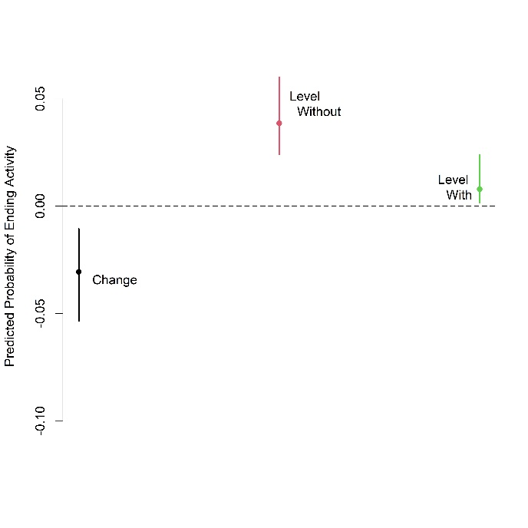
Figure 3: Probability of Ending Activity due to Religion (Model 3 – with Controls)
Turning again to Hypothesis 2, I estimate Model 4 (Column 4 in Table 6 above) to estimate a relationship between membership practices and the log-likelihood of ceasing activity in a year while controlling for democracy and GDP. As with Hypothesis 1, the relationship between persistence and membership practices is not explained by wealth or democracy; the log-likelihood of ending activity in a year is lower for organizations with membership practices than those without, regardless of the level of wealth or democracy, supporting Hypothesis 2. I also predicted probabilities from Model 4 (Figure 4 below and Row 4 in Table 5 above) which show that the predicted probability of ending activity is .045 lower for organizations with membership practices than those without, controlling for wealth and democracy. Thus, even considering that state-level wealth and democracy might assist organizations in persisting, I again find strong evidence in favor of both Hypothesis 1 and 2.
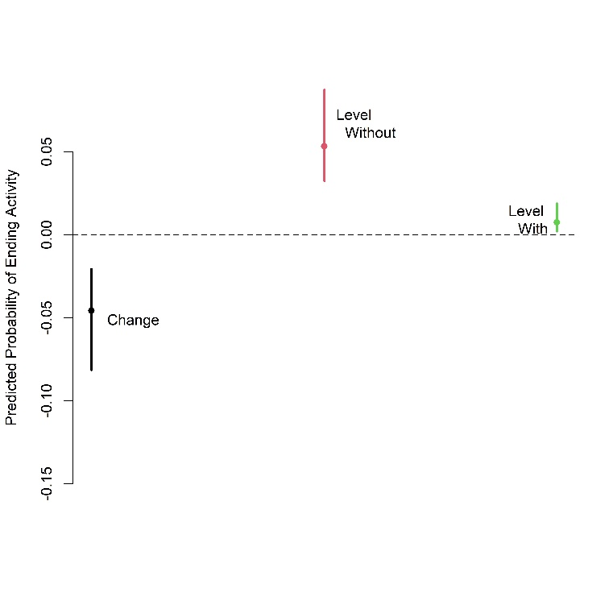
Figure 4: Probability of Ending Activity due to Membership Practices (Model 4 – with Controls)
Having shown that religion or religion-like ideology and membership practices each increase an organization’s chance of persistence, alone and controlling for state-level wealth and civil liberties, in support of both Hypothesis 1 and 2, I now turn to whether both religion and membership practices impact persistence in the presence of the other. In Model 5 (Column 5 in Table 6 above), I estimate the log-likelihood of an organization ending activity in the next year conditional on both whether the organization is religious and whether it has membership practices, controlling only for the age of the organization as in Models 1 and 2. I find that the coefficient for whether an organization is religious is negative, suggesting that a religious organization enjoys a smaller log-likelihood of ceasing activity in the next year, regardless of whether or not it also has membership practices. However, this evidence is weaker than the previous evidence as it is only statistically significant at the 10 percent significance level. Similarly, I calculate that the predicted probability of religious organizations ending activity in the next year is .021 less than nonreligious organizations, controlling for the presence of membership practices, but this difference is not statistically different from 0 at the ordinary 5 percent significance level (Figure 5 below and Row 5 in Table 5 above). Thus, I find some evidence in favor of Hypothesis 1 that religious organizations are more likely to persist than nonreligious organizations, even when controlling for whether the organization additionally has membership practices, but this evidence is weaker than in the first models.
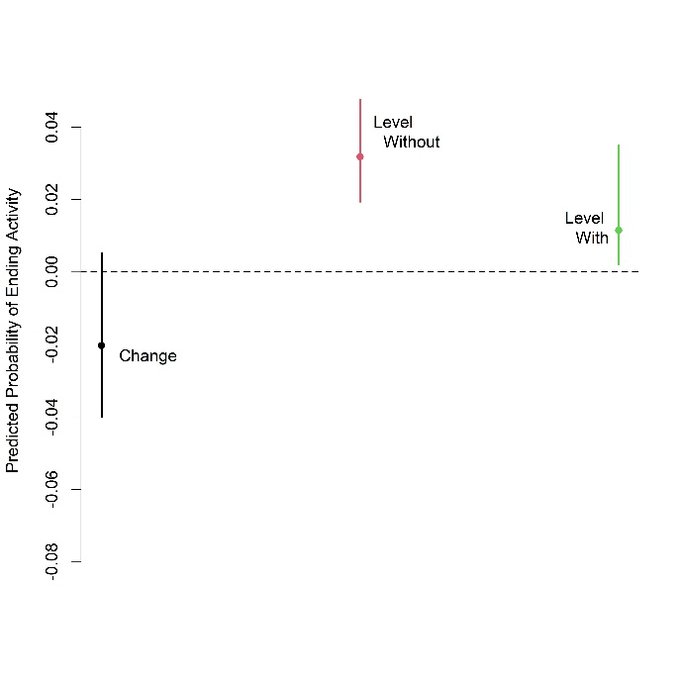
Figure 5: Probability of Ending Activity due to Religion (Model 5 – Controlling for Membership Practices)
Also from Model 5, I find that the log-likelihood of ceasing activity in a year is smaller for organizations which have membership practices, controlling for whether the organization is religious (or has a religion-like ideology). Similarly, I calculate that the predicted probability for an organization ceasing activity is .039 less for an organization with membership practices than without, controlling for religion (Figure 6 below and Row 6 in Table 5 above). Therefore, I find strong evidence for Hypothesis 2 controlling for religion: organizations with membership practices are more likely to persist, even regardless of whether they are religious.

, 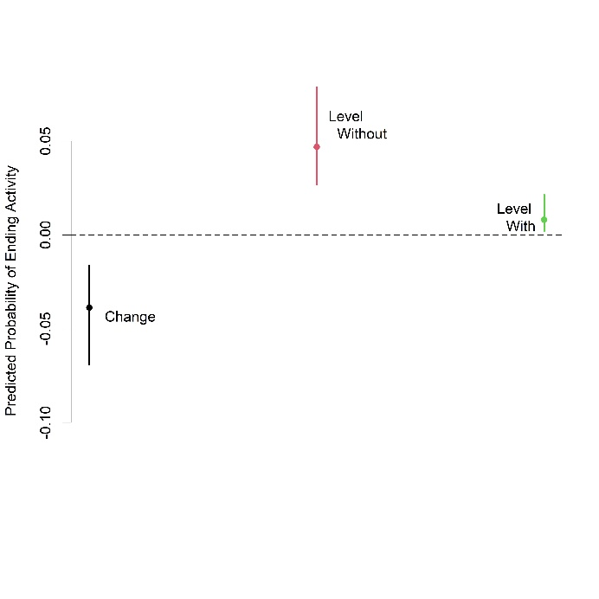
Figure 6: Probability of Ending Activity due to Membership Practices (Model 5 –Controlling for Religion)
Finally, I estimate a final model (Model 6 – Column 6 in Table 6 above) with both religion and membership practice like Model 5 and controlling for democracy and GDP like Models 3 and 4 to examine whether religion and membership practices both have effects when controlling for each other as well as the potential that wealth and greater civil liberties allow organizations to greater freedom to practice religion and membership practices as well as persist. Here, I find strong evidence for both Hypotheses 1 and 2. The coefficients for both religion (or religion-like ideology) and membership practices are statistically significant and negative, so organizations with religion (or religion-like ideology) or membership practices are significantly less likely to cease activity in a year, regardless of whether those organizations also have the other characteristic. This is also borne out in the predicted probabilities: religious organizations have a .024 smaller probability of ceasing activity in a year (Figure 7 below and Row 7 in Table 5 above), and organizations with membership practices have a .035 smaller probability of ceasing activity (Figure 8 below and Row 8 in Table 5 above), controlling for the other characteristic as well as wealth and civil liberties. Both values are statistically different from 0. Thus, I find further support for both Hypotheses 1 and 2: religion (or religion-like ideology) and membership practices each have significant relationships with persistence, independently of the other characteristic.
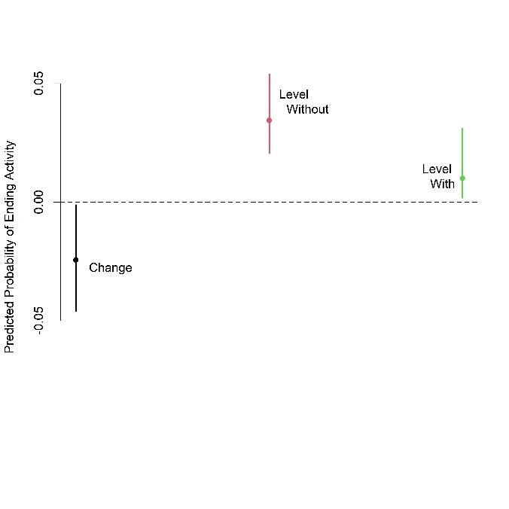
Figure 7: Probability of Ending Activity due to Religion (Model 6 –Controlling for Membership Practices, GDP, and Democracy)
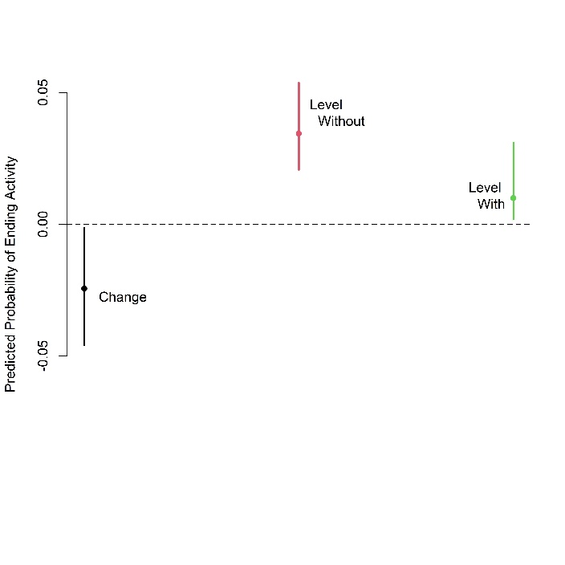
Figure 8: Probability of Ending Activity due to Membership Practices (Model 6 –Controlling for Religion, GDP, and Democracy)
Together, results of these models provide strong evidence in favor of both hypotheses: both religion (or religion-like ideology) and membership practices have significant relationships with persistence. The possibility that democracy or wealth at the country level permit an organization to more freely practice both religion and membership practices as well as persist does not explain these relationships. Moreover, both religion and membership practices have significant relationships with persistence controlling for the other characteristic. An organization can still enjoy increased persistence from either religion or membership practices regardless of whether it also has the other. Thus, these results show that ideational factors do allow organizations in self-determination movements to persist in their demands over time.

Conclusion
Both religion, including religion-like ideology, and membership practices, that is, standards of behavior and participation which an organization imposes upon its members, are significant factors in the ability of organizations to continue making demands against a state over time. Thus, first, these results identify specific factors of mobilization that influence the persistence of the set of potential rebel actors, those that ultimately do not become violent as well as those that do. Second, these results show that religion (and religion-like ideologies) have an effect on mobilization for self-determination movements outside of civil war, extending the known findings that religion may encourage mobilization in war. Third, specific signals of commitment by organizational members made through participation in nonpolitical activities and standards of behavior, often but not necessarily related to religion or a religion-like ideology, have an independent impact from belief in religion or ideology itself on maintaining mobilization over time. This adds to the body of research on the mechanisms by which religion and religion-like ideologies may influence mobilization.
These results have implications for the study of civil war duration and dynamics of contentious action. If factors, like religion, that influence civil war duration also influence the persistence of claim making organizations, then studies of religion and civil war onset need to distinguish the effect of religion on mobilization for demand making from the effect of religion on a politically active organization to choose to engage in pursuing those claims by violence. Second, the results also have implications for the study of the role of religion and ideology on conflict duration. Deriving goals from religion or religion like ideology does allow an organization to persist. Additionally important, membership practices that provide signals of commitment, dictating standards of behavior and participation in nonpolitical activity, produce independent results on organizational persistence. This paper then adds to the study of research on the mechanisms of religion and ideology in violence and contentious politics. Specific behaviors, often associated with religion, but not necessarily so, are an additional related to but distinct from religion itself, leading more evidence to the importance of considering specific mechanisms of religion rather than simply studying religion as a fixed identity. Future research on religion and conflict will need to continue to identify such mechanisms rather than treating religion as a simple category associated with contentious organizations, supporting calls made in previous research (Toft 2021, 1608).
This article explains important variation in an understudied topic adjacent to the study of civil war duration and the study of varieties of contentious action: the duration of claim-making organizations in self-determination movements. Because this is a set of potential civil war actors, including those that rebel and those that may not rebel, this is an important category of actors to study in its own right in order to understand mobilization accounting for the fact that violence is a strategic choice made by specific actors, not something that happens to a country, region, or ethnic group. It is specific organizations that make claims and choose to pursue violence or nonviolence in their pursuit. These organizations are more likely to persist when their members have mobilized around demands explicitly based on religion or a religion-like ideology. They are additionally more likely to persist when their members show commitment to each other through standards of behavior and participation in nonpolitical activities. Future research needs to continue to explain the mobilization of claim-making organizations, regardless of their tactical choice, and further investigate the impacts of both religious and ideological factors and specific behavioral practices on the ability to pursue claims against states.

References
Abbs, Luke, and Kristian Skrede Gleditsch. 2021. “Ticked off, but Scared off?: Riots and the Fate of Nonviolent Campaigns.” Mobilization: An International Quarterly 26 (1): 21-39. DOI: 10.17813/1086-671X-26-1-21
Armstrong, Dave. 2022. “DAMisc: Dave Armstrong's Miscellaneous Functions.” R Package. Version 1.7.2. https://CRAN.R-project.org/package=DAMisc
Asal, Victor, Richard Legault, Ora Szekely, and Johnathan Wilkenfeld. 2013. “Gender Ideologies and Forms of Contentious Mobilization in the Middle East.” Journal of Peace Research 50 (3): 305-318.
Berman, Eli. 2000. “Sect, Subsidy, and Sacrifice: An Economist’s View of Ultra-Orthodox Jews.” The Quarterly Journal of Economics 115 (3): 905-953.
Berman, Eli. 2009. Radical, Religious, and Violent: The New Economics of Terrorism. Cambridge, MA: MIT Press. Berman, Eli, and David D. Laitin. 2008. “Religion, Terrorism, and Public Goods.” Journal of Public Economics 92: 1942-1967.
Berman, Eli, and David D. Laitin. 2008. “Religion, Terrorism, and Public Goods: Testing the Club Model.” Journal of Public Economics 92: 1942-1967. DOI: 10.1016/j.jpubeco.2008.03.007
Buhaug, Halvard, Scott Gates, and Päivi Lujala. 2009. “Geography, Rebel Capability, and the Duration of Civil Conflict.” Journal of Conflict Resolution 53 (4): 544-569. DOI: 10.1177/0022002709336457
Breslawski, Jori, and Brandon Ives. 2018. “Killing for God?: Factional Violence on the Transnational Stage.” Journal of Conflict Resolution DOI: 10.1177/0022002718763632
BSS (Bodo Sahitya Sabha). 2004, September. “The Constitution of the Bodo Sahitya Sabha.” Retrieved February 2, 2021, from http://bodosahityasabha.org/constitution.html
Calfano, Brian Robert, and Paul A. Djupe. 2009. “God Talk: Religious Cues and Electoral Support.” Political Research Quarterly 62 (2): 329-339. DOI: 10.1177/1065912908319605
Chenoweth, Erica, and Orion A. Lewis. 2013. “Unpacking Nonviolent Campaigns: Introducing the NAVCO 2.0 Dataset.” Journal of Peace Research 50 (3): 415-423. DOI: 10.1177/0022343312471551
Costalli, Stefano, and Andrea Ruggeri. 2015. “Indignation, Ideologies, and Armed Mobilization: Civil War in Italy, 1943-45.” International Security 40 (2): 119-157.
Cunningham, David 5. 2015. Barriers to Peace in Civil War. Cambridge: Cambridge University Press.
Cunningham, David E., Kristian Skrede Gleditsch, and Idean Salehyan. 2009. “It Takes Two: A Dyadic Analysis of Civil War Duration and Outcome.” Journal of Conflict Resolution 53 (4): 570-597. DOI: 10.1177/0022002709336458
Cunningham, Kathleen Gallagher. 2021. “Shirts Today, Skins Tomorrow: Dual Contests and the Effects of Fragmentation in Self-Determination Disputes.” Journal of Conflict Resolution 56(1): 67-93. DOI: 10.1177/0022002711429697
Cunningham, Kathleen Gallagher. 2013. “Understanding Strategic Choice: The Determinants of Civil War and Nonviolent Campaign in Self-Determination Disputes.” Journal of Peace Research 50 (3): 291-304.
Cunningham, Kathleen Gallagher. 2014. Inside the Politics of Self-Determination. Oxford: Oxford University Press.
Cunningham, Kathleen Gallagher, Marianne Dahl, and Anne Frugé. 2017 “Strategies of Resistance: Diversification and Diffusion.” American Journal of Political Science 61 (3): 591-605.
Dahl, Marianne, Scott Gates, Kristian Skrede Gleditsch, and Belén González. 2020. “Accounting for Numbers: Group Characteristics and the Choice of Violent and Nonviolent Tactics.” Economics of Peace and Security Journal. Retrieved June 6, 2022, from http://repository.essex.ac.uk/29204/
Gates, Scott, and Ragnhild Nordås. 2010. “Recruitment and Retention in Rebel Groups.” Working Paper. Center for the Study of Civil War, Peace Research Institute Oslo (PRIO).
Graffelman, Jan, and Fred Van Eeuwijk. 2005. “Calibration of Multivariate Scatter Plots for Exploratory Analysis of Relations within and between Sets of Variables in Genomic Research.” Biometrical Journal 47 (6): 863-879. DOI: 10.1002/bimj.200510177
Gutiérrez-Sanín, Francisco, and Elisabeth Jean Wood. 2014. “Ideology in Civil War: Instrumental Adoption and Beyond.” Journal of Peace Research 51 (2): 213-226.
Fearon, James D. 1994. “Rationalist Explanations for War.” International Organization 49 (3): 379-414.
Feenstra, Robert C., Robert Inklaar, and Marcel P. Timmer. 2015. “The Next Generation of the Penn World Table.” American Economic Review 105 (10): 3150-3182.
Heger, Lindsay L., and Danielle F. Jung. 2017. “Negotiating with Rebels: The Effect of Rebel Service Provision on Conflict Negotiations.” Journal of Conflict Resolution 61 (6): 1203-1229.
Hlavac, Marek. 2022. “stargazer: Well-Formatted Regression and Summary Statistics Tables.” R Package. Version 5.2.3. https://CRAN.R-project.org/package=stargazer
Iannaccone, Laurence R., and Eli Berman. 2006 July. “Religious Extremism: The Good, the Bad, and the Deadly.” Public Choice 128 (1/2): 109-129.
Jenne, Erin. 2004. “A Bargaining Theory of Minority Demands: Explaining the Dog that Did Not Bite in 1990s Yugoslavia.” International Studies Quarterly 48: 729-754.
Jennings, Jay T. 2016. “Mixed Reactions: How Religious Motivation Explains Responses to Religious Rhetoric in Politics.” Political Research Quarterly 69 (2): 296-308. DOI: 10.1177/1065912916636690
Kalyvas Stathis N., and Laia Balcells. 2010. “International System and Technologies of Rebellion: How the End of the Cold War Shaped Internal Conflict.” American Political Science Review 104 (3): 415-429.
Keels, Eric, and Krista Wiegand. 2020. “Mutually Assured Distrust: Ideology and Commitment Problems in Civil Wars.” Journal of Conflict Resolution 64 (10): 2022-2048. DOI: 10.1177/0022002720928414
Maoz, Zeev, and Errol Anthony Henderson. 2020. Scriptures, Shrines, Scapegoats, and World Politics: Religious Sources of Conflict and Cooperation in the Modern Era. Ann Arbor: University of Michigan Press.
McLauchlin, Theodore. 2010 April. “Military Strategies and Military Defection in Rebellion.” Comparative Politics 42 (3): 333-350. DOI: 10.5129/001041510X12911363509792
McLauchlin, Theodore. 2014. “Desertion, Terrain, and Control of the Home Front in Civil Wars.” Journal of Conflict Resolution 58 (8): 1419-1444. DOI: 10.1177/0022002714547901
McLauchlin, Theodore. 2015. “Desertion and Collective Action in Civil Wars.” International Studies Quarterly 59: 669-679.
Mecham Quinn. 2017. Institutional Origins of Islamist Political Mobilization. Cambridge: Cambridge University Press.
R Core Team. 2022. “R: A Language and Environment for Statistical Computing.” Vienna: R Foundation for Statistical Computing. https://www.R-project.org/
Saikia, Pahi. 2009, September. “Protest Networks, Communicative Mechanisms and State Responses: Ethnic Mobilization and Violence in Northeast India.” Ph.D. Diss. McGill University.
Schubiger, Livia Isabella, and Matthew Zelina. 2017 October. “Ideology in Armed Groups.” PS: Political Science and Politics: 948-951. DOI: 10.1017/S1049096517001056
Shadian, Jessica. 2006. “Reconceptualizing Sovereignty through Indigenous Autonomy: A Case Study of Arctic Governance and the Inuit Circumpolar Conference.” Ph.D. Diss. University of Delaware.
(START) National Consortium for the Study of Terrorism and Responses to Terrorism. 2018. Global Terrorism Database. Retrieved January 14, 2019, from https://www.start.umd.edu/gtd
Sundberg, Ralph, and Erik Melander. 2013. “Introducing the UCDP Georeferenced Event Dataset.” Journal of Peace Research 50 (4): 523-532.
Svensson, Isak, and Desirée Nilsson. 2018. “Disputes over the Divine: Introducing the Religion and Armed Conflict (RELAC) Data, 1975 to 2015.” Journal of Conflict Resolution 62 (5): 1127-1148. DOI: 10.1177/0022002717737057
Szekely, Ora Beach. 2011. “Send Lawyers Guns and Money: The Politics of Militia Survival in the Middle East.” Ph.D. Diss. McGill University.
Szekely, Ora. 2014. “Doing Well by Doing Good: Understanding Hamas’s Social Services as Political Advertising.” Studies in Conflict and Terrorism 38 (4): 275-292. DOI: 10.1080/1057610X.2014.995565
Toft, Monica Duffy. 2021. “Getting Religion Right in Civil Wars.” Journal of Conflict Resolution 65 (9): 1607-1634. DOI: 10.1177/0022002721997895
Ugarriza, Juan E., and Matthew J. Craig. 2012. “The Relevance of Ideology to Contemporary Armed Conflicts: A Quantitative Analysis of Former Combatants in Colombia.” Journal of Conflict Resolution 57 (3): 445-477.
Walter, Barbara F. 2017. “The Extremist’s Advantage in Civil Wars.” International Security 42 (2): 7-39. DOI: 10.1162/ISEC_a_00292
Weinstein, Jeremy M. 2007. Inside Rebellion: The Politics of Insurgent Violence. Cambridge: Cambridge University Press.
White, Peter B., Dragana Vidovic, Belén González, Kristian Skrede Gleditsch, and David E. Cunningham. 2015. “Nonviolence as a Weapon of the Resourceful: From Claims to Tactics in Mobilization.” Mobilization: An International Quarterly 20 (4): 471-491.

Appendix 1: Predicted Probability Tables
Table 7: Amounts of Predicted Probability for Ending Activity by Religion and Signals
Model | Ideology | Signals | Probability | 95% C.I. Min | 95% C.I. Max
M1: Religion Alone | 0 | NA | 0.037 | 0.022 | 0.057
M1: Religion Alone | 1 | NA | 0.008 | 0.002 | 0.023
M2: Membership Practices Alone | NA | 0 | 0.054 | 0.032 | 0.088
M2: Membership Practices Alone | NA | 1 | 0.007 | 0.002 | 0.018
M3: Religion with Controls | 0 | NA | 0.039 | 0.025 | 0.058
M3: Religion with Controls | 1 | NA | 0.008 | 0.002 | 0.024
M4: Membership Practices with Controls | NA | 0 | 0.053 | 0.032 | 0.088
M4: Membership Practices with Controls | NA | 1 | 0.008 | 0.002 | 0.021
M5: Both | 0 | Observed | 0.032 | 0.020 | 0.049
M5: Both | 1 | Observed | 0.011 | 0.002 | 0.030
M5: Both | Observed | 0 | 0.047 | 0.028 | 0.075
M5: Both | Observed | 1 | 0.008 | 0.002 | 0.021
M6: Both with Controls | 0 | Observed | 0.034 | 0.022 | 0.051
M6: Both with Controls | 1 | Observed | 0.010 | 0.002 | 0.033
M6: Both with Controls | Observed | 0 | 0.045 | 0.026 | 0.076
M6: Both with Controls | Observed | 1 | 0.009 | 0.003 | 0.024

Note: Observed means the predicted probability was calculated with that variable set to the values observed in the data.
Statistical analysis performed in R (R Core Team 2022); predicted probabilities calculated with the {DAMisc} package (Armstrong 2022); tables created with {stargazer} (Hlavac 2022); {calibrate} (Graffelman and Van Eeuwijk 2005) used on plots.

While a large body of research has studied the factors of the duration of civil wars, we know little about the persistence of rebel actors themselves other than how long they persist in their violent action against the government. Since violent activity against the state is a choice, made out of other potential strategies, then we need to know the persistence of rebel organizations as organizations, as well as the persistence of potential rebels who pursued their claims against the government without violence.
I assume that the decision to participate in an organization’s political activities is a rational choice by each constituent. While the responsiveness and repression of the government determines many of the costs and benefits of participation (DeNardo 1985, 190-2), the organization still has influence over other costs and benefits.
This differential effect of religion has been demonstrated quantitatively in for American electoral politics (Calfano and Djupe 2009; Jennings 2016).
Note: Observed means the predicted probability was calculated with that variable set to the values observed in the data. Statistical analysis performed in R (R Core Team 2022); predicted probabilities calculated with the {DAMisc} package (Armstrong 2022); tables created with {stargazer} (Hlavac 2022); {calibrate} (Graffelman and Van Eeuwijk 2005) used on plots.

